

System design SPECIFICATION
for
Declaration Part 1 (Import, Export, Warehouse)

Release No 2.0– Apr,2022

Document Identification no | Document Title | Status  (draft/ approved/ baselined/ released ) | Date of Release | Pages
eCMS /sds/01/V2.0 | System design specification for Declaration Part 1 | Draft

Prepared By
Role | Name | Signature | Date (dd-mm-yyyy)

Reviewed by

Role | Name | Signature | Date (dd-mm-yyyy)

Approved By
Role | Name | Signature | Date (dd-mm-yyyy)
application system Manager

Authorized for Release
 | Name | Designation | Signature | Date (dd-mm-yy)
Authorized by Project Manager

Contents
1. INTRODUCTION 4
1.1 Scope 4
1.2 Definitions and abbreviations 4
1.3 References 5
1.4 Product Perspective 5
2. Design viewpoints 6
2.1 Interface viewpoint 6
2.2 Dependency Viewpoint 8
2.3 System Database Schema 9
2.4 Field Details 9

INTRODUCTION

The eCMS, as its name implies, will be a system for the DRC’s Customs & Excise Division, hereafter referred to as “Customs”, that will provide best-in-class services to the Bhutan‘s business community, in support of the Bhutan‘s aspirations to modernize core customs administration functions as part of customs modernization requirements and in line with the international conventions and national regulations such as The Customs Act of Bhutan 2017 and Customs Rules and Regulations of Bhutan 2017.

Implementation of the electronic customs management system will further help to propel Bhutan’s rankings by making it easier and clearer for traders and businesses to have access to information and enable them to submit regulatory compliance forms/documents digitally.

This document is intended to act as the SDD (Software Design Document) for the Application module.

Scope
This document defines & illustrates the business requirements, process flows as well as the detailed functional requirements of eCMS Application module (Authorized Compliant Trader and Exemption) to be implemented for Department of Revenue and Customs, Bhutan.

Definitions and abbreviations

S/N | Abbreviations | Description
 | ACT | Authorized Compliant Trader
 | BITS | Bhutan Integrated tax System
 | CFA | Clearing and Forwarding Agent
 | CID | Citizens Identification Number
 | DRC | Department of Revenue & Customs
 | eCMS | Electronic Customs Management System
 | IDEC | Import Duty Exemption Certificate
 | Nu | Ngultrum
 | RRCO | Regional Revenue and Customs Office
 | RTO | Regional Trade Office
 | TPN | Taxpayer Number

References
Signed off SRS_eCMS_Registration_V1.0

Product Perspective

Design viewpoints

Interface viewpoint

The Interface design focuses on the screen designs for various services provided by the Declaration module.

Based on the CPC Group certain sub-processes are optional, and some are mandatory. The generic process will consist of the sub-process as given:

- Approval
- Payment
- Valuation
- Centralized Risk
- Inspection
- Additional payment (if any)
- Release

Import Declaration Submission

Create Declaration for import:
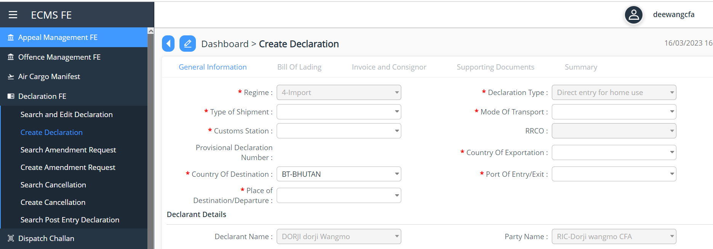
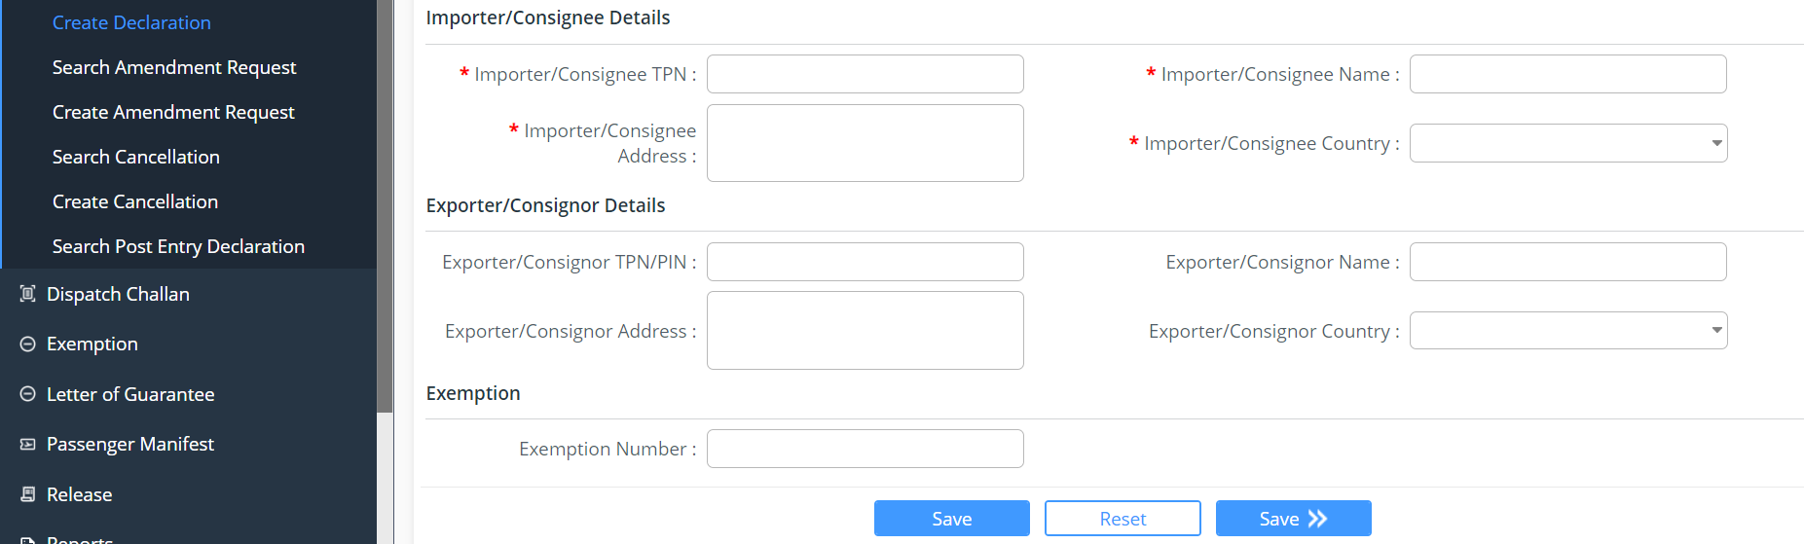
Screenshot for Declaration type: Direct entry for Home Use

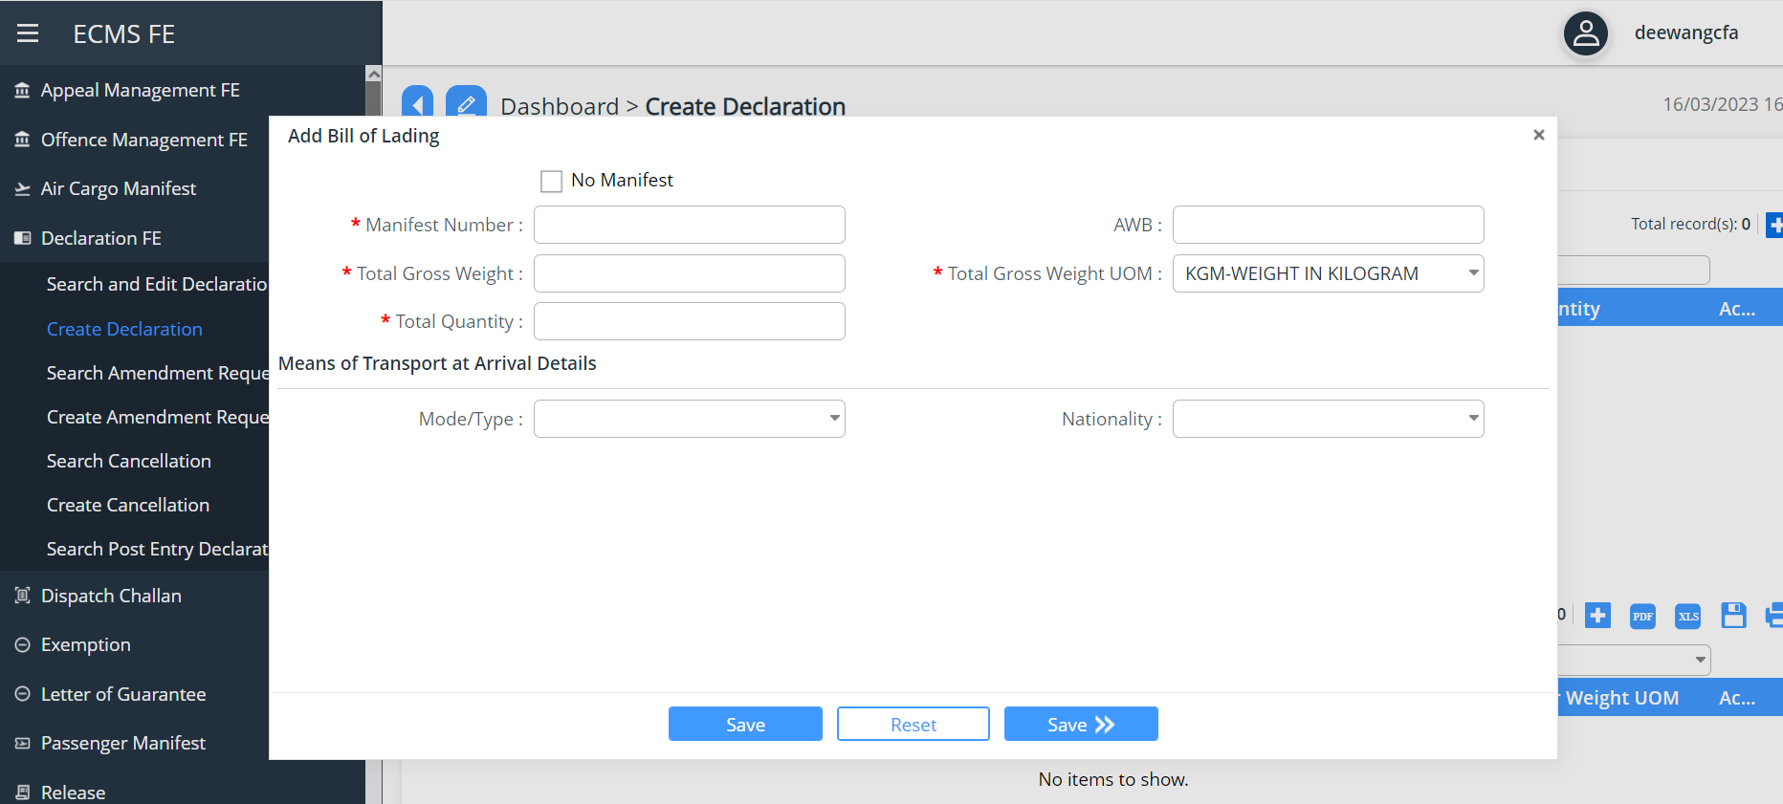
Screenshot for Bill of Lading

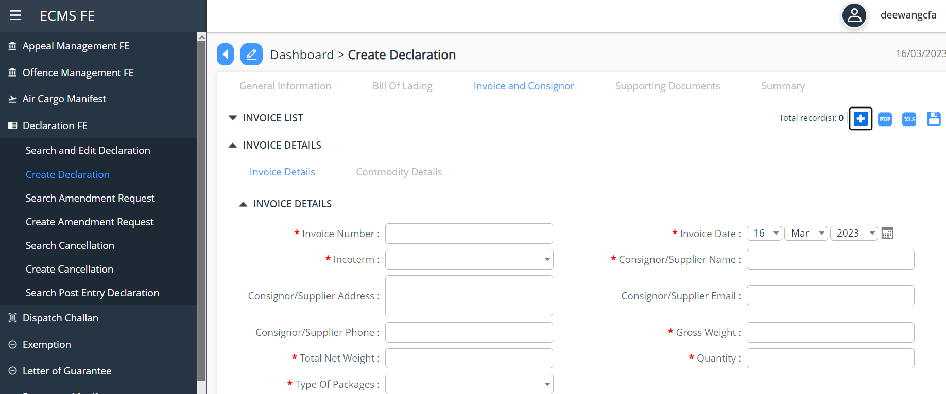

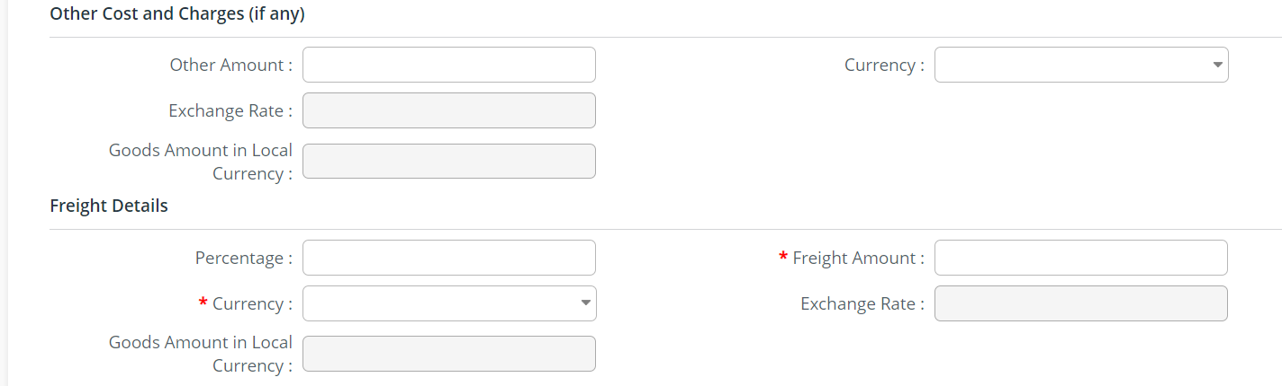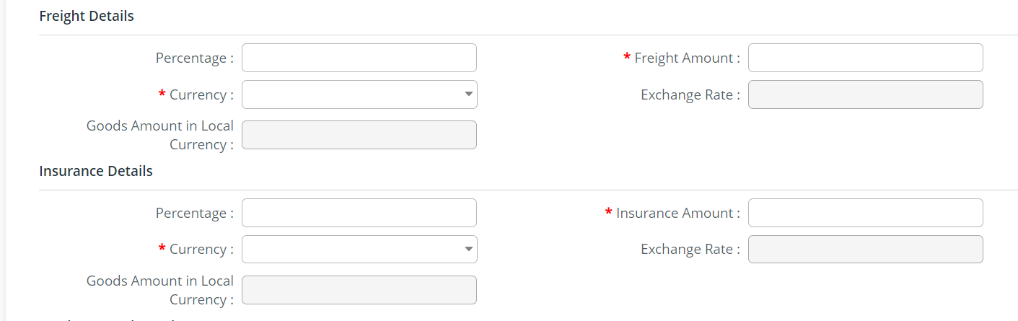
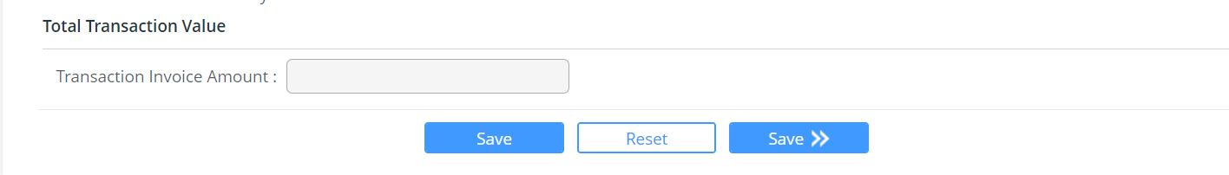
Screenshot for Invoice details

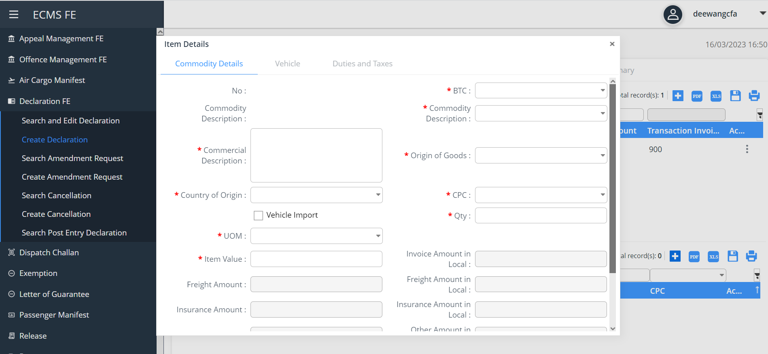
Screenshot for item details
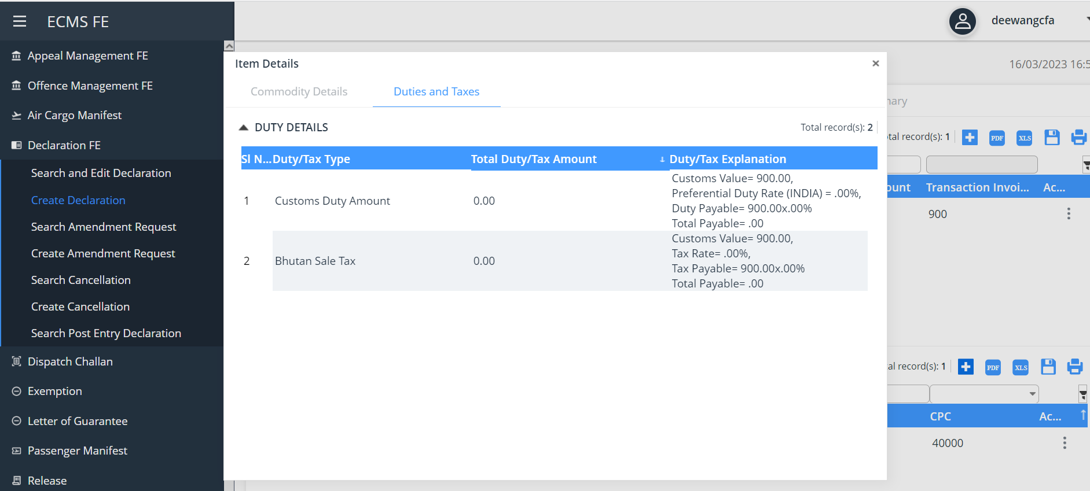
Screenshot for duty

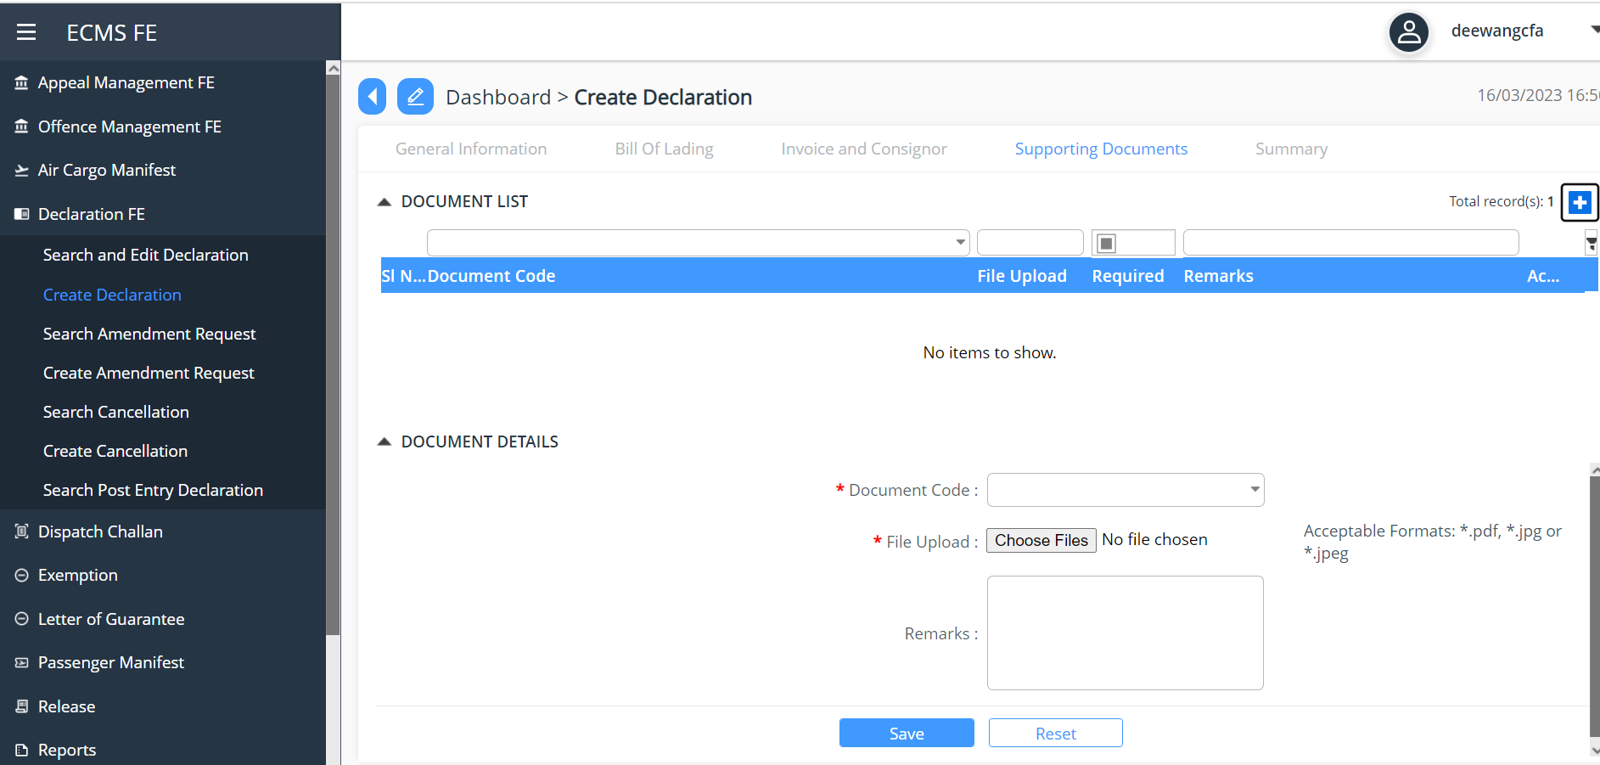
Screenshot to upload supporting document

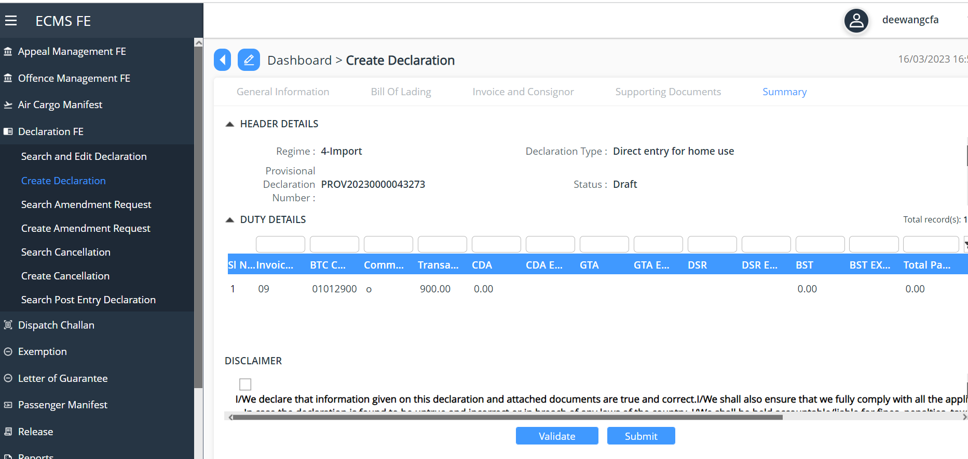
Screenshot for Import duty submission

Import Declaration Approval is done at the Cust end, where in the assigned officer will do the due diligent and approve the declaration:
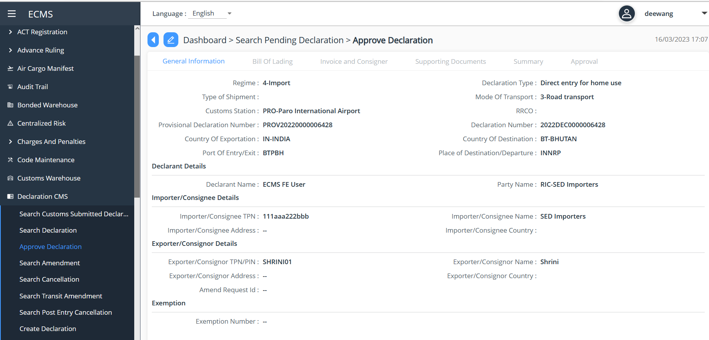
Screenshot general information
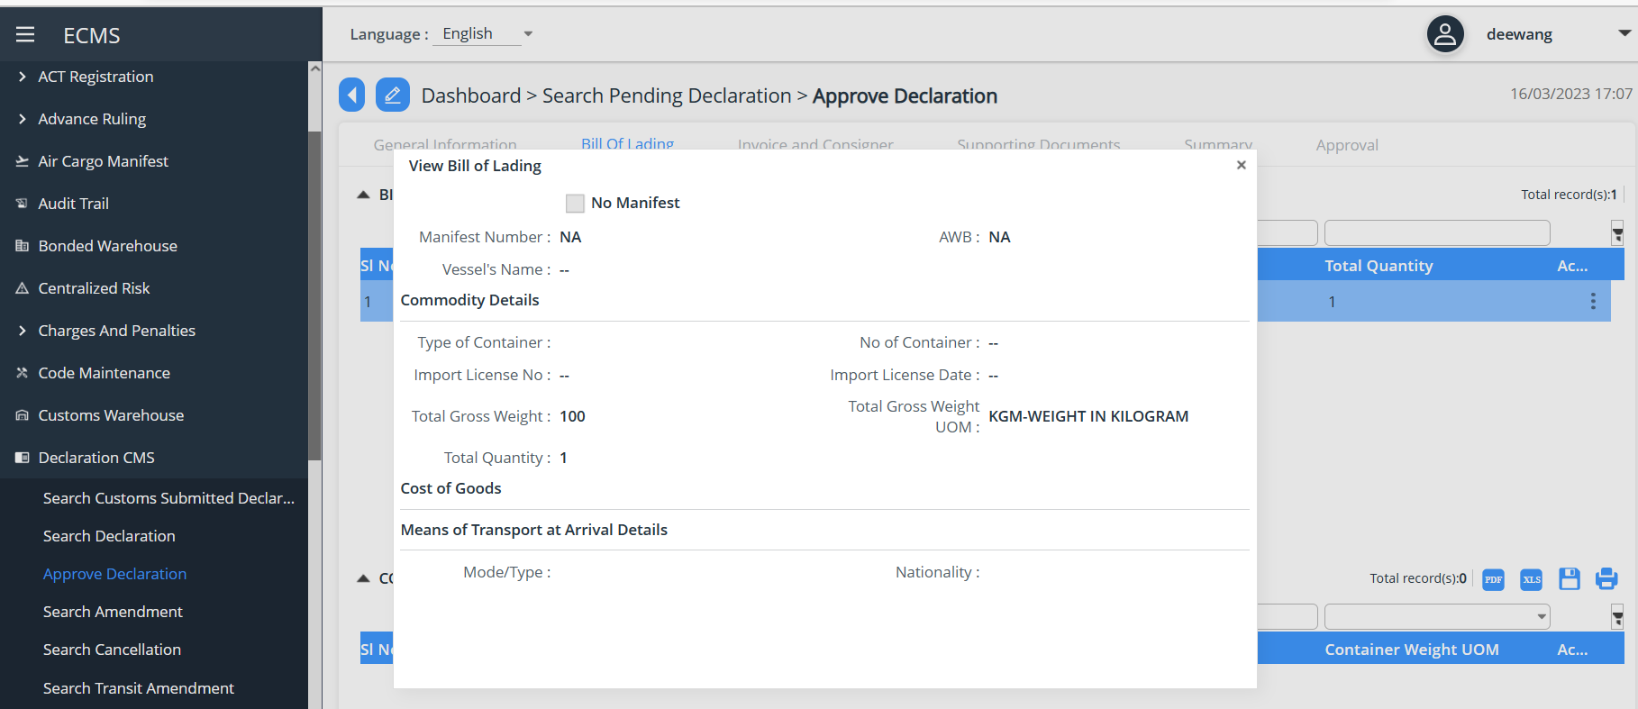
Screenshot for Bill of Lading
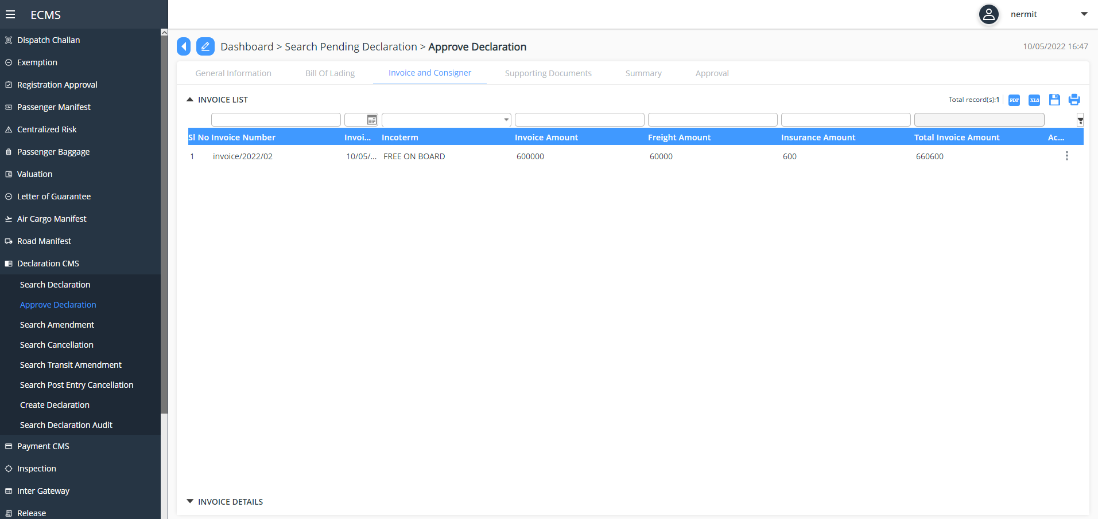
Screenshot for invoice and consigner
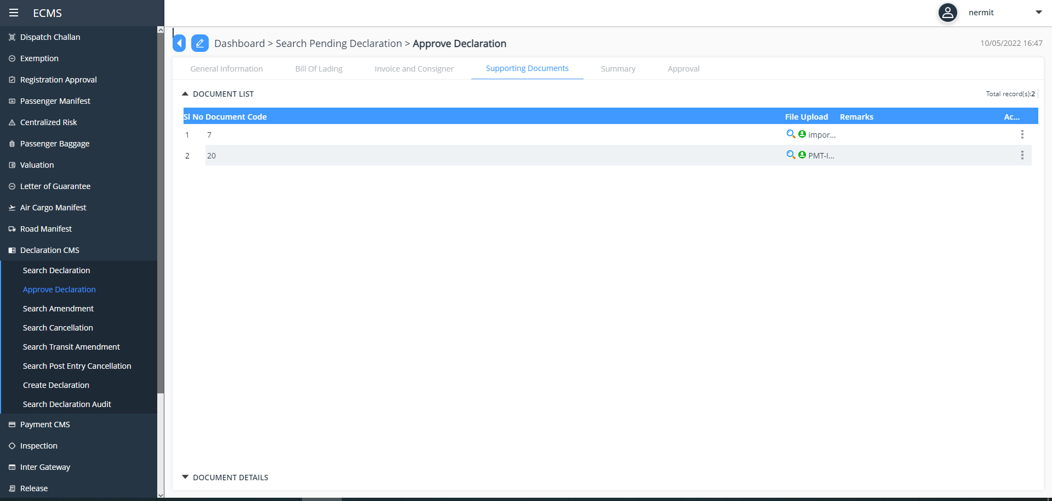
Screenshot for supporting document
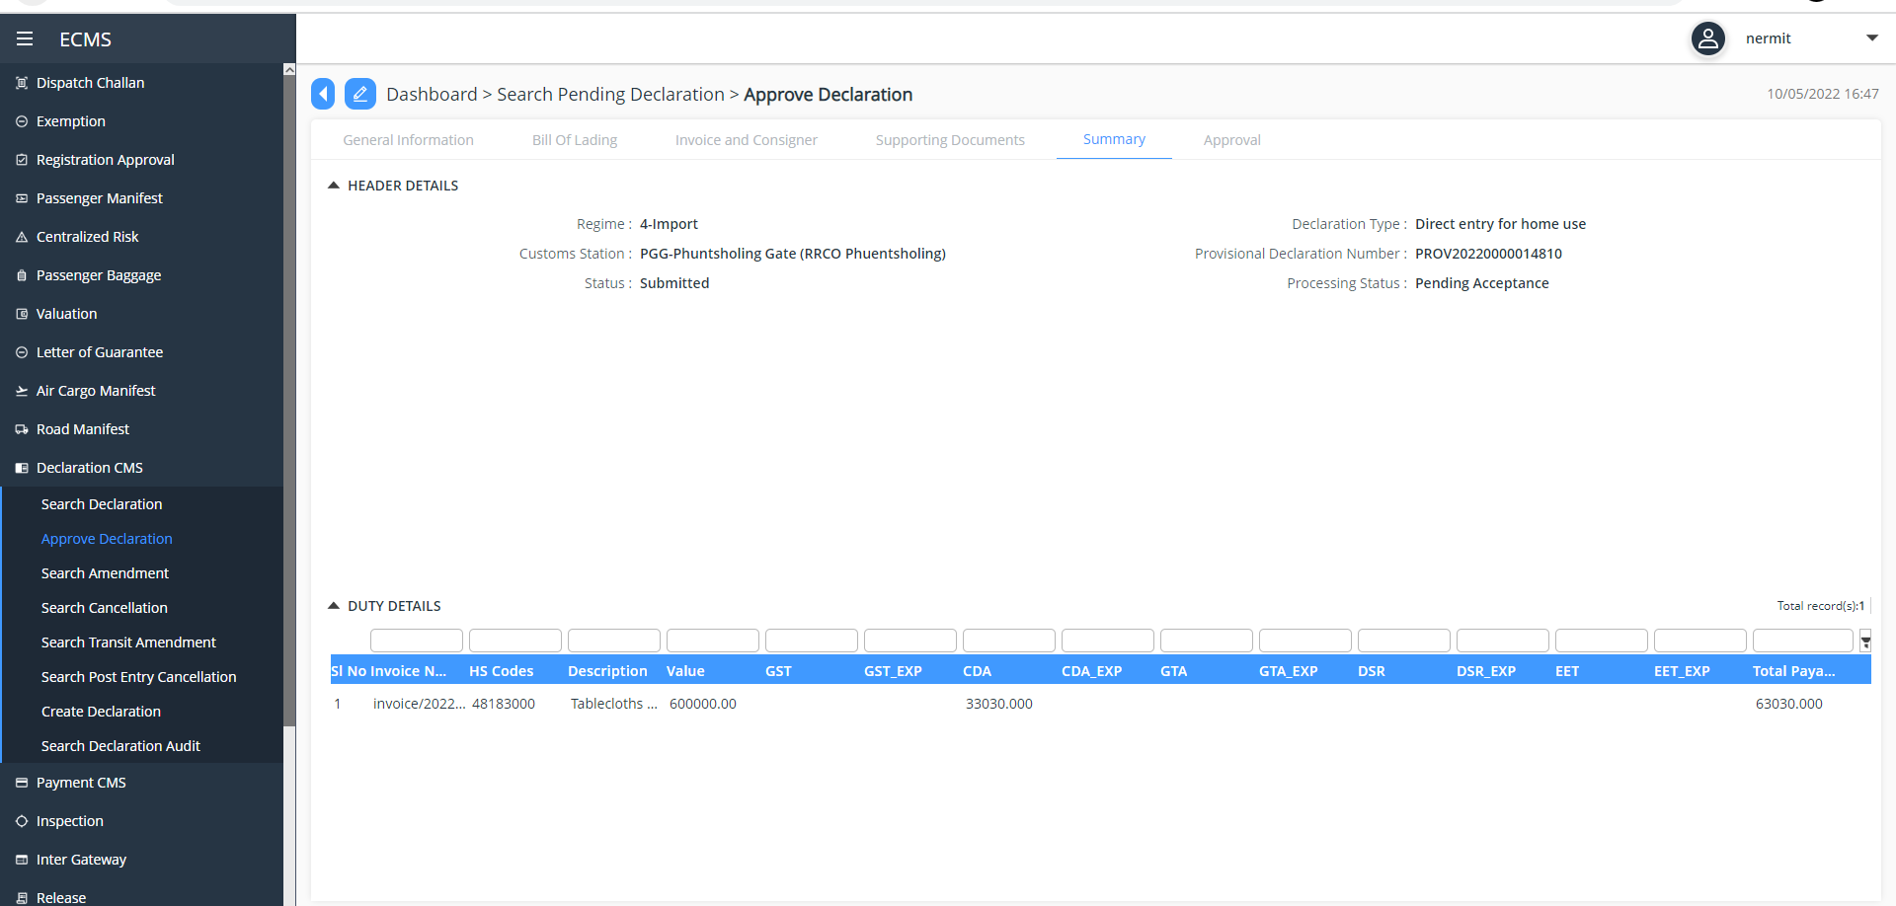
Screenshot for summary
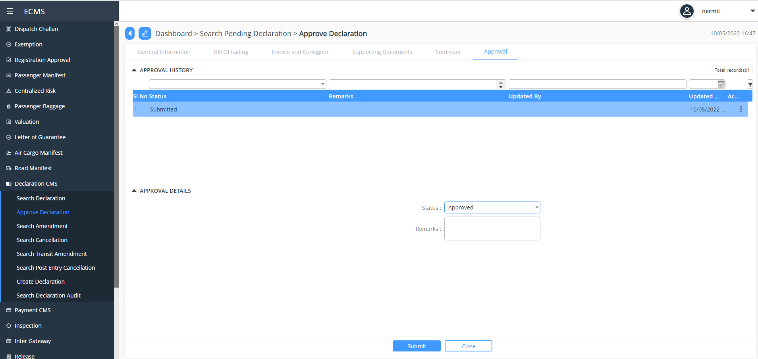
Screenshot for approval of Import Declaration

Payment
- The system will allow payment for the declaration accepted by customs.
- Upon completion of payment process the system will automatically forward the declaration to the next process
- If the declaration is not subjected for payment, the system will automatically forward the declaration to the next process.
- the system will also route the additional payment for a declaration to payment process.
- the additional payment will be linked to a particular declaration.

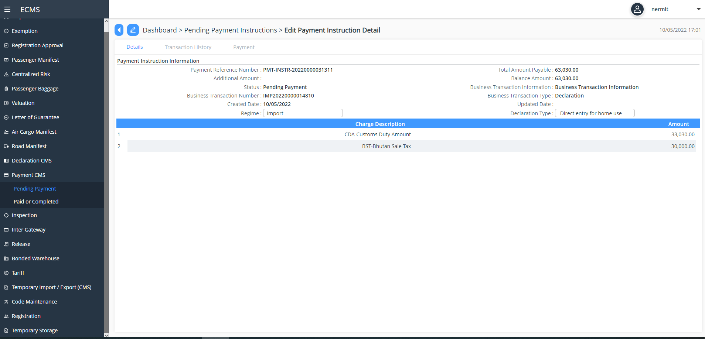
Screenshot for Details
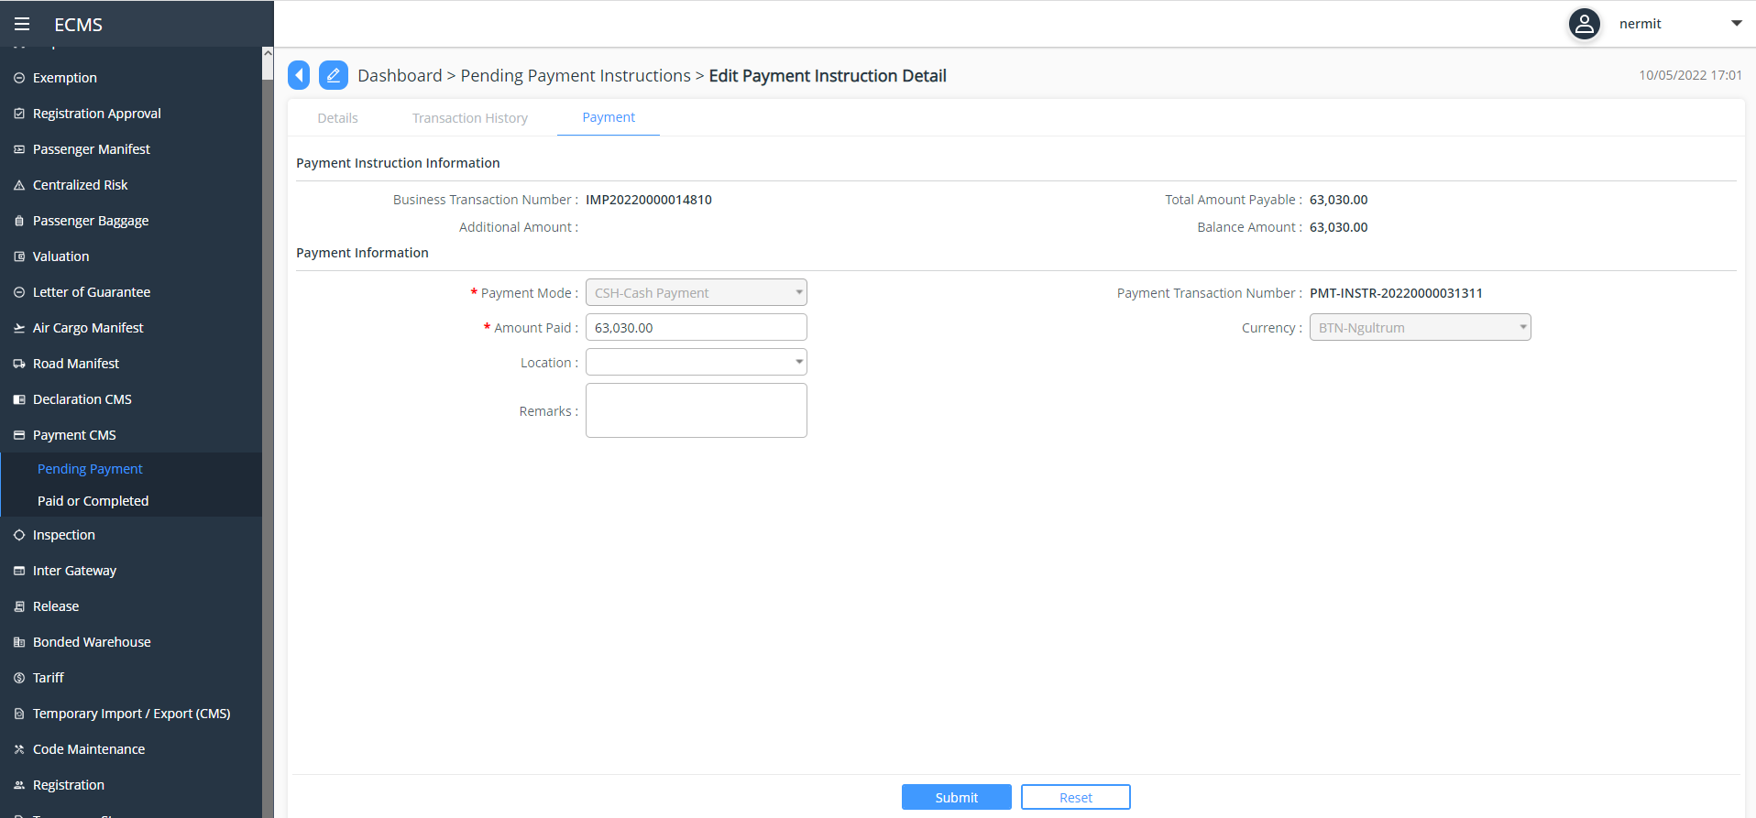
Screenshot for Payment approval

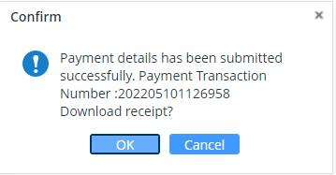

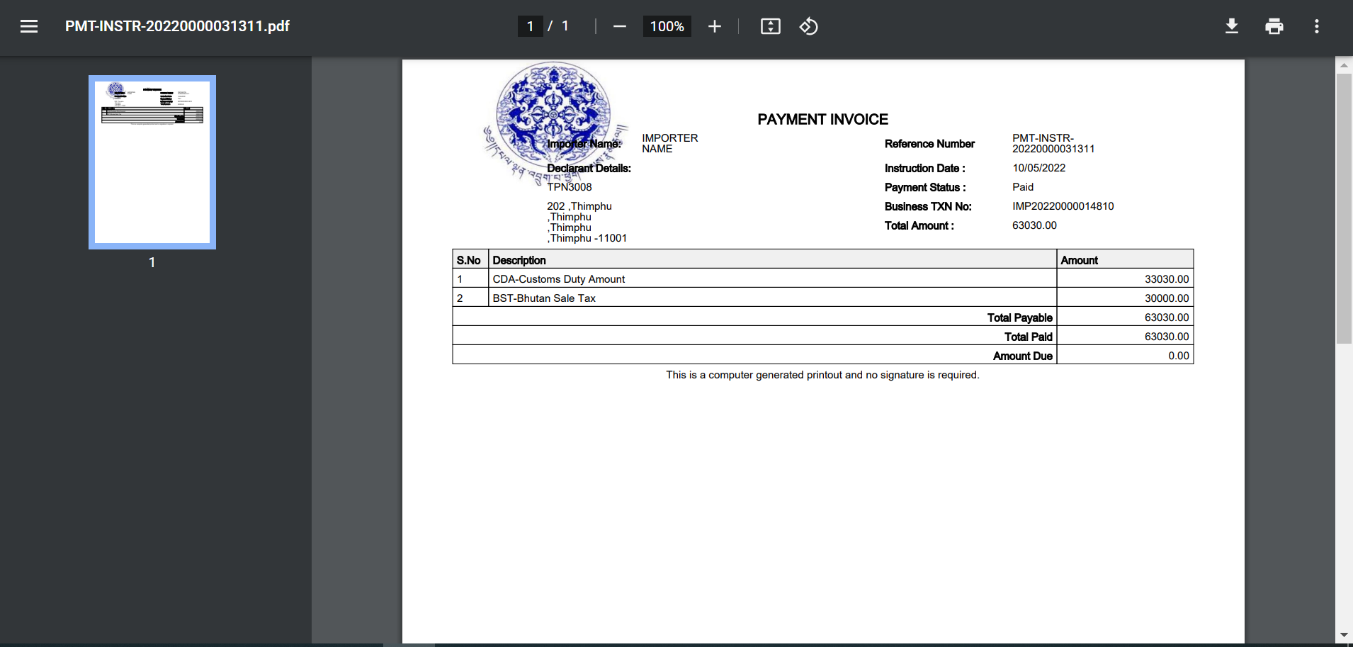
Screenshot for Receipt downloaded.
Valuation
- The system will determine the customs value at item level and accordingly determine whether the declared value is under or over value.
- The system based on the order of execution (please refer the SRS Valuation) will reflect the system value for items that are either under or overvalued.
- The system will allow the customs officer to decide on valuation based on the finding presented by the system and amend the declared value accordingly.
- The system will give an option to the valuation officer to direct the declaration to yellow or red channel.

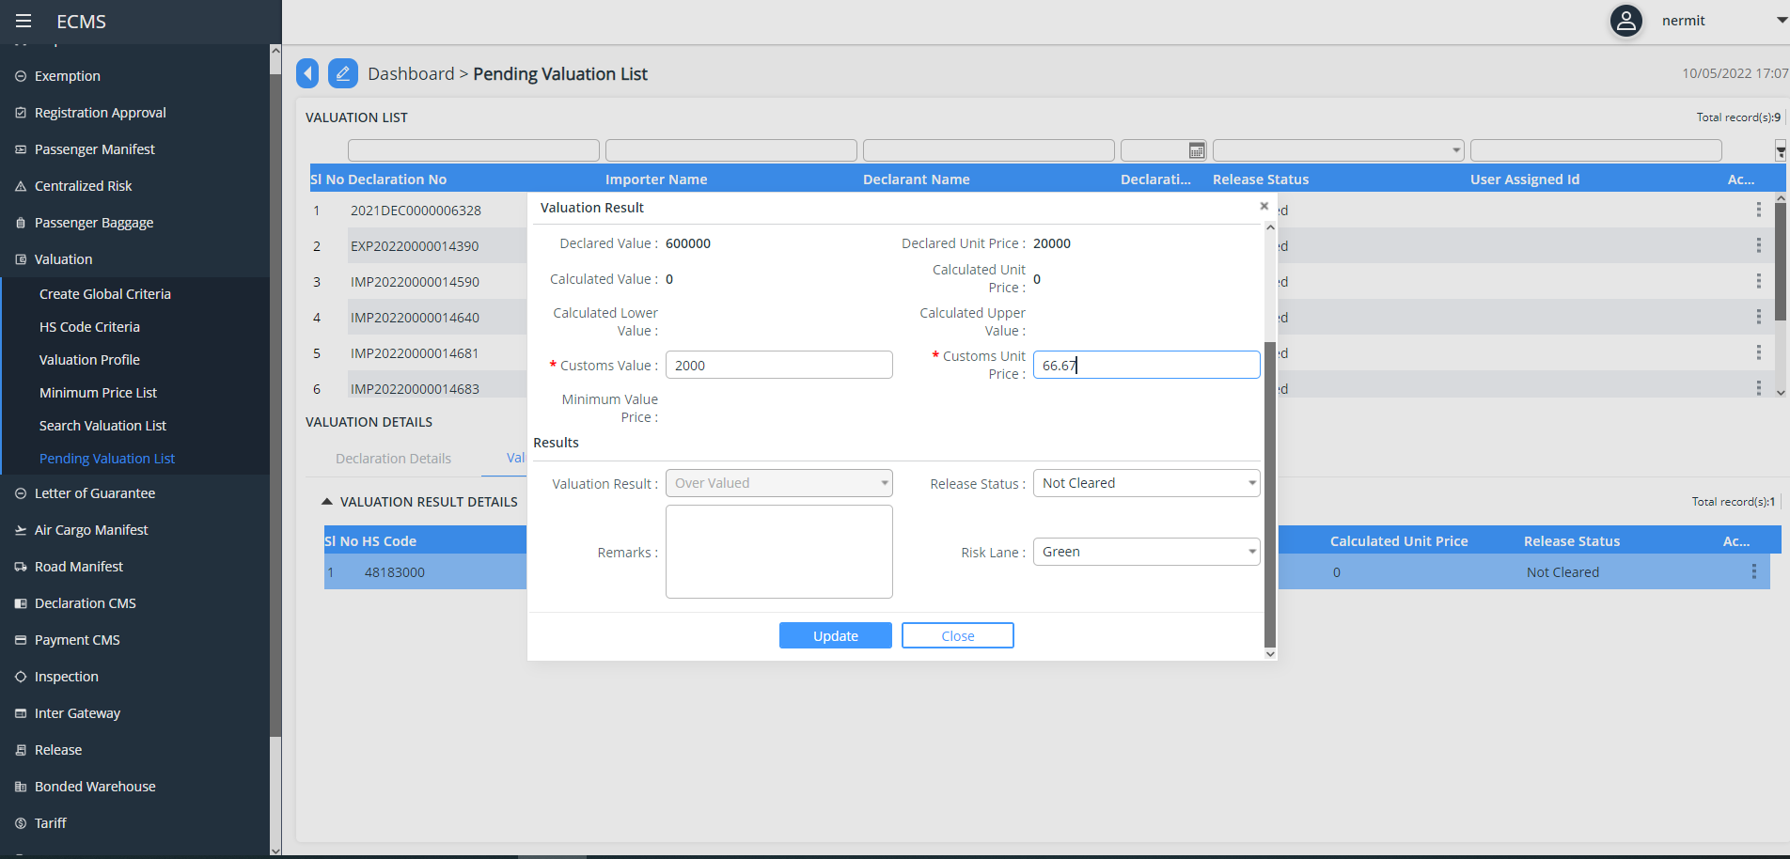
Screenshot for Valuation Result

Centralized Risk Assessment
- The system will perform the risk assessment based on the risk profile in the system
- The lane will be decided based on profile criteria met. The possible outcomes are “Green”, “Blue”, “Yellow” or “Red” lanes.
- “Green” lane will go for release process.
- “Blue” lane will go for Post clearance audit after release.
- “Yellow” will go for document verification.
- “Red” will go for physical inspection.

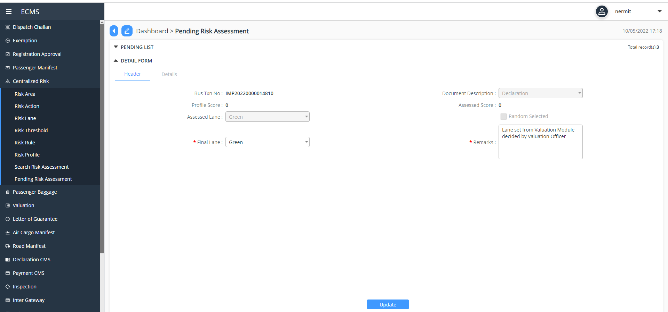
Screenshot for Risk Assessment
Examination
- Yellow Channel
- If the declaration is directed to yellow lane, the declaration will be reflected in the document verifier’s dashboard
- the system will also provide a platform to the document verifier officer to submit the examination report.
- The document verification officer may review the documents and decide to release or route for physical inspection or for re-assessment
- The system will then follow the additional payment process
- Red Lane
- If the declaration is directed to red lane, the declaration will be reflected in the inspection’s dashboard
- Upon physical inspection carried out by the inspection team, the system will also provide a platform to the inspection officer to submit the inspection report that is standard and incorporated in the system.
- Based on the inspection REPORT, the assessor will either.
- release the good
- send back to the declarant for amendment.
- Direct the declaration to the offences and penalties: Declaration intercepted with customs offence after examination can be routed to Offence and Penalties process by Inspection Officer
- Blue Lane
- The system will automatically direct the declaration submitted by ACT to blue lane
- The system will also provide a feature for the customs to direct a particular declaration to the blue lane.
- Green Lane
- The declaration directed to green lane will be released by the customs.

Note: The system will provide an option for customs to upgrade the declaration as follows.
- Green Lane to either yellow or red channel
- Yellow lane to red channel

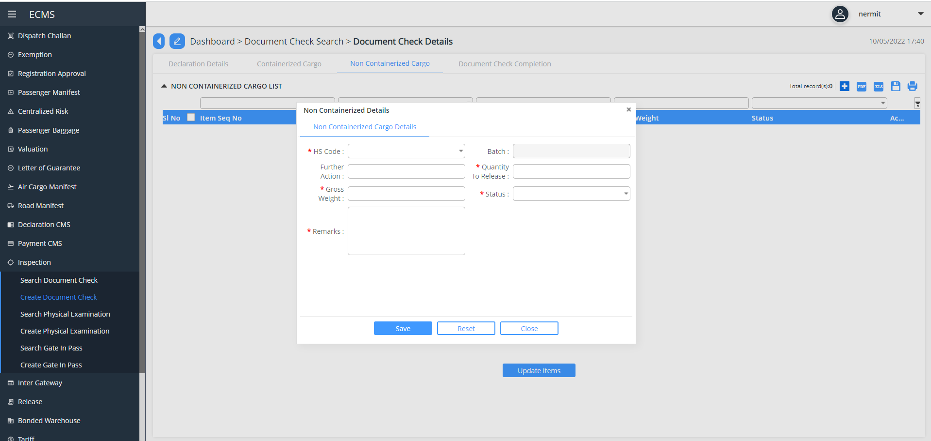
Screenshot for Check non-containerized cargo

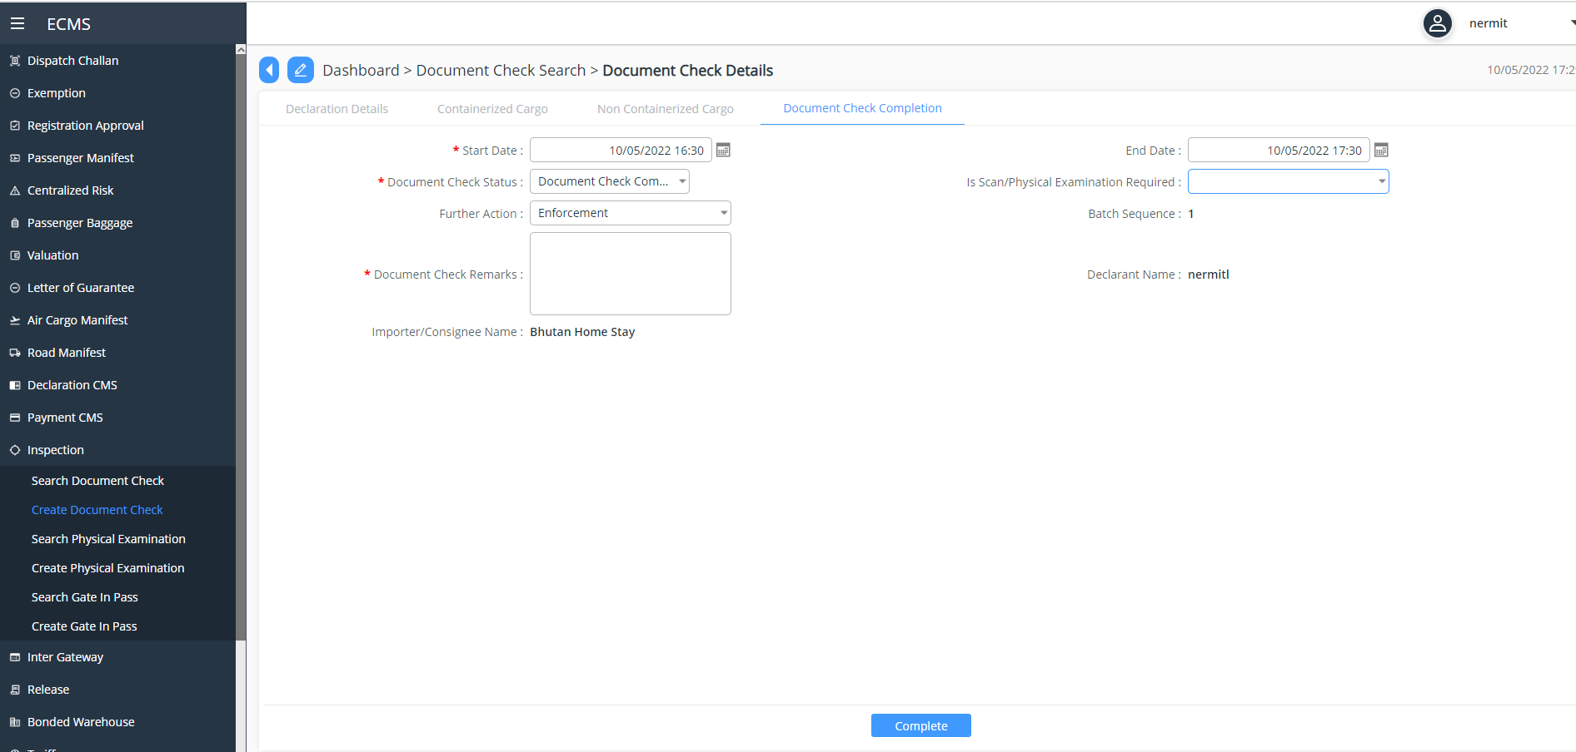
Screenshot for Document check
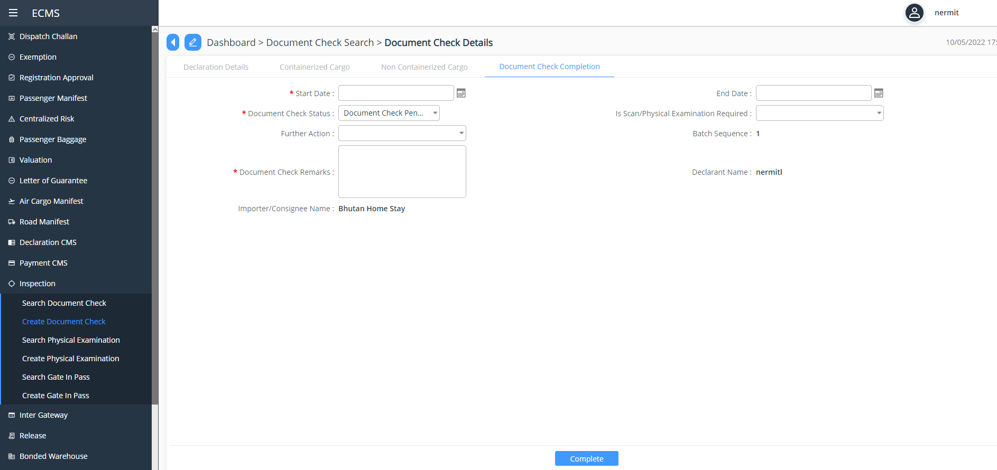
Screenshot for Document check complete

Physical Examination: Physical examination is created in the system and then the examination happened offline , then once done the inspection offer will update the report and close the examination , the declaration then proceeds further in the flow.
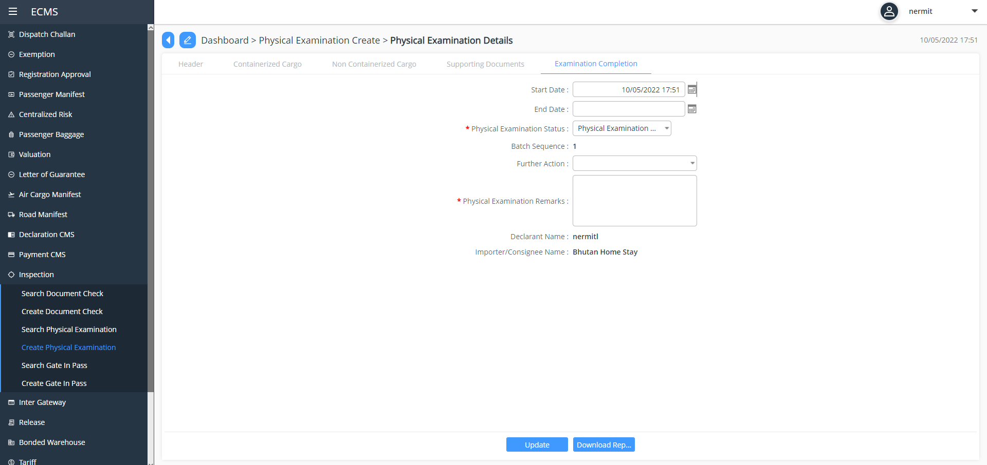
Screenshot for Physical Examination
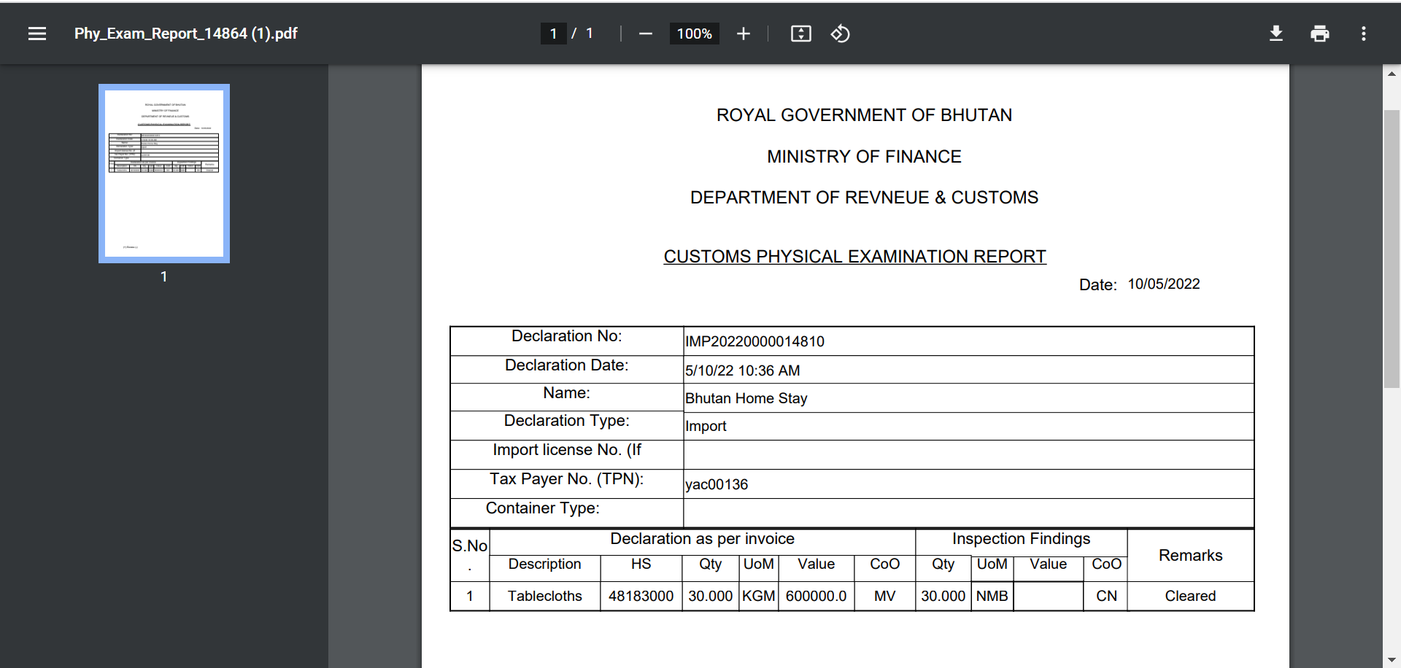
Screenshot for Physical examination Report

Release Cargo
- Upon completion of the customs procedures the system will generate a release order.
- The system will allow both the declarant and the customs office to print the release order if need be.
- During gate out the gate officer will be presented with the release order. Based on which the gate officer will release the cargo and the same will be recorded in the system.
- The system will record the release time
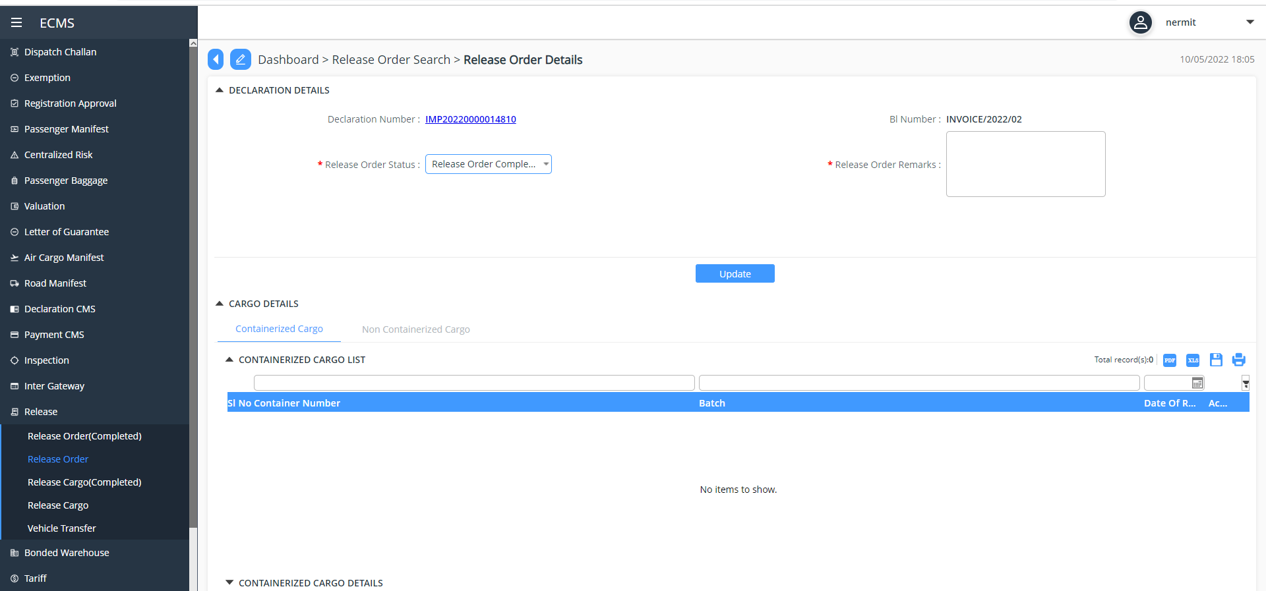
Screenshot for Release Cargo Order
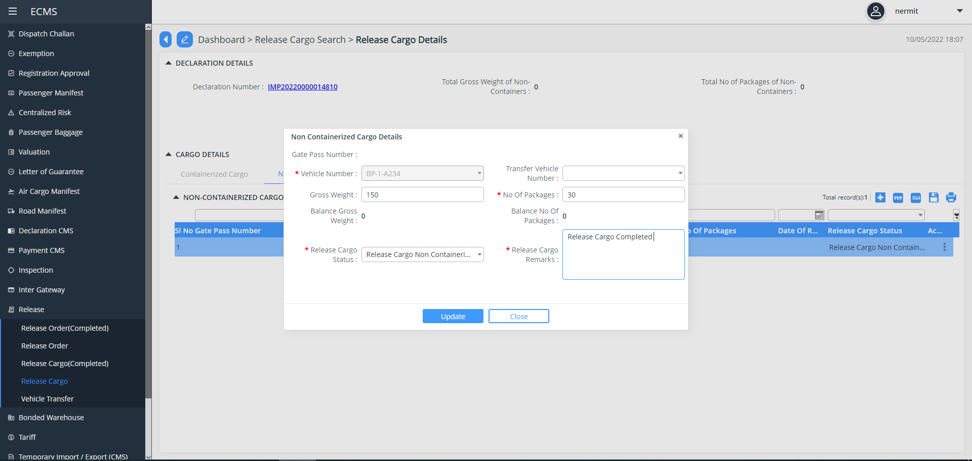
Screenshot for Release Cargo details (non-containerized) Updates

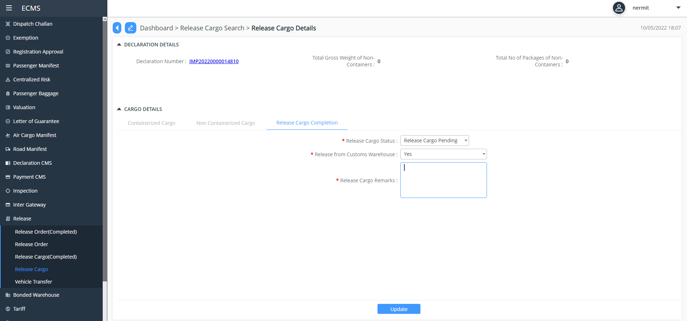
Screenshot for Release Cargo

Screenshot for declaration processing for different regimes and CPC.
Based on the CPC Group certain sub-processes are optional, and some are mandatory. For e.g., for temporary import or export, an approved TIER application will be required.

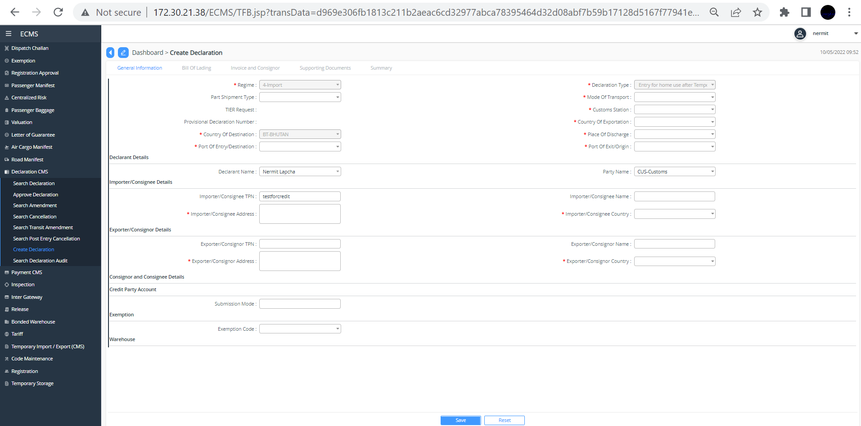
Screenshot for Declaration type: Entry for Home use after Temporary Admission

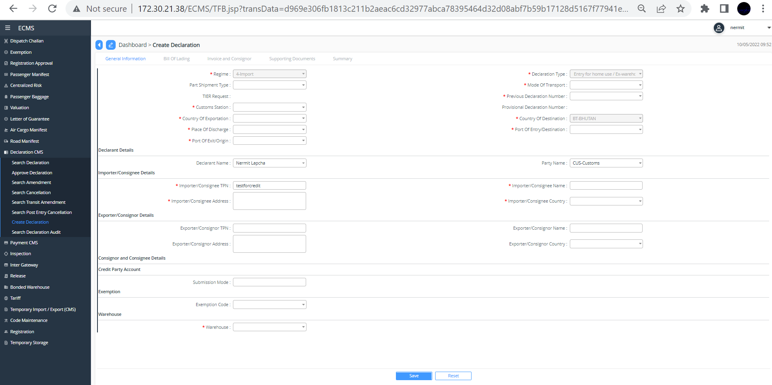
Screenshot for Declaration Type: Entry for Home use ex-warehouse after ware housing Procedure

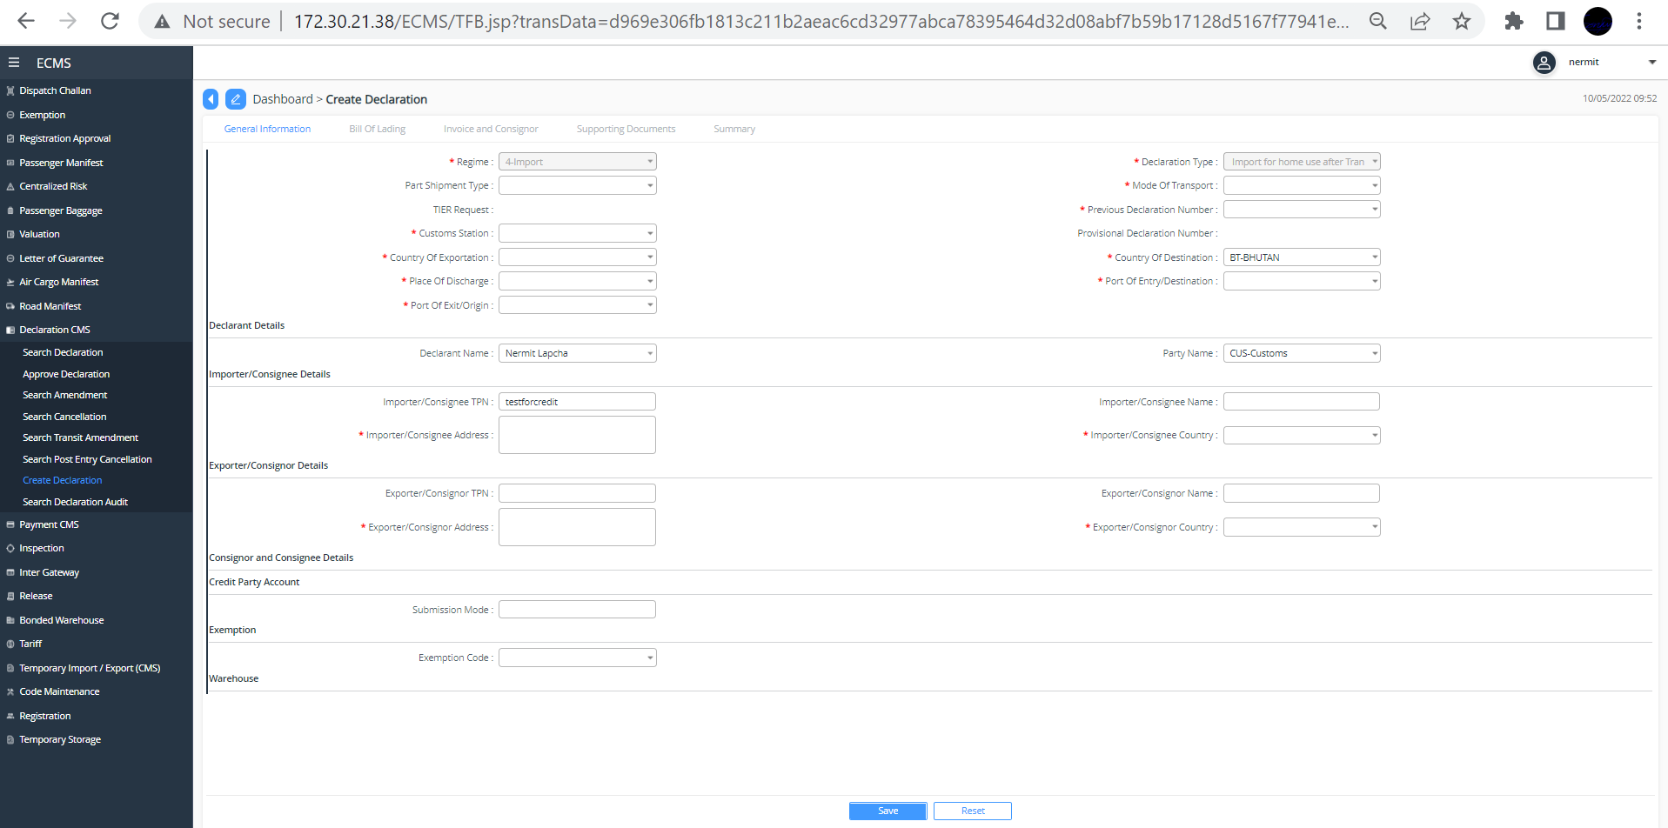
Screenshot for Declaration type: Import for Home use after transit

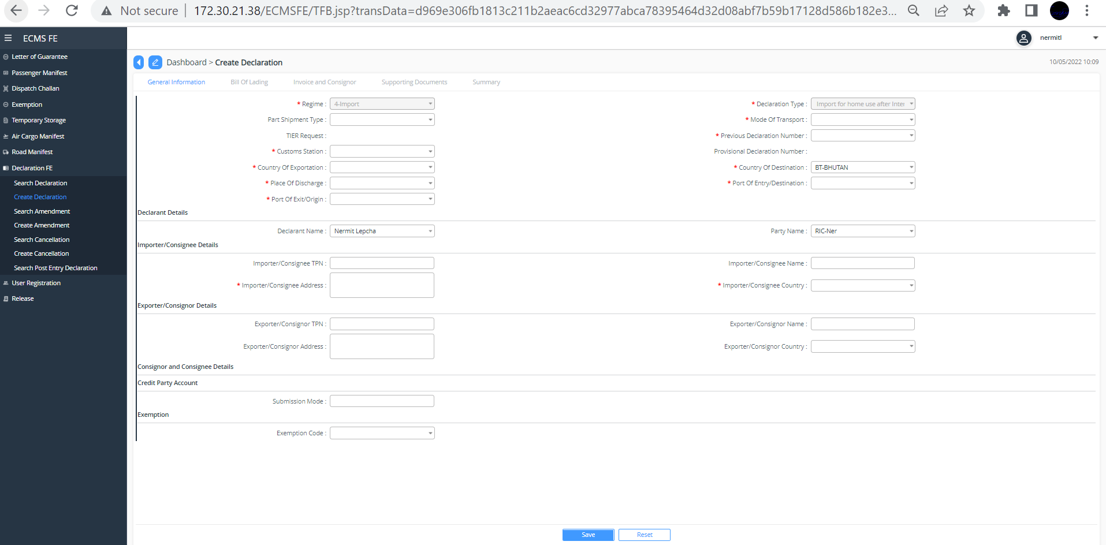
Screenshot for Declaration type: Import for home use after international transit
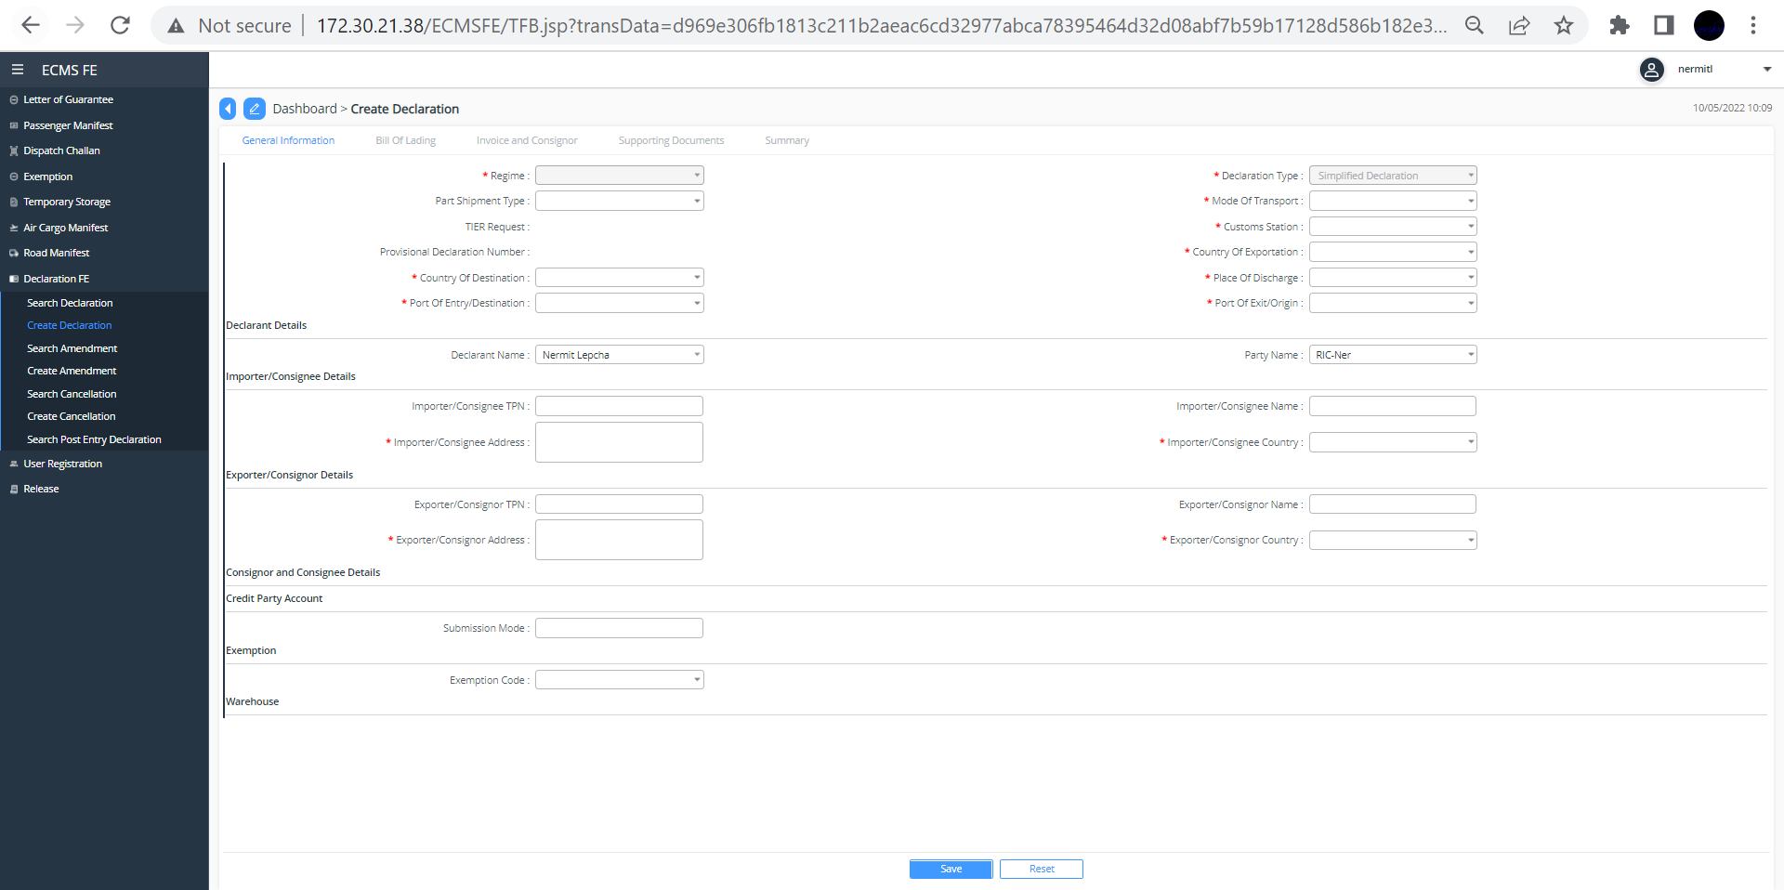
Screenshot for Declaration Type: Simplified Declaration
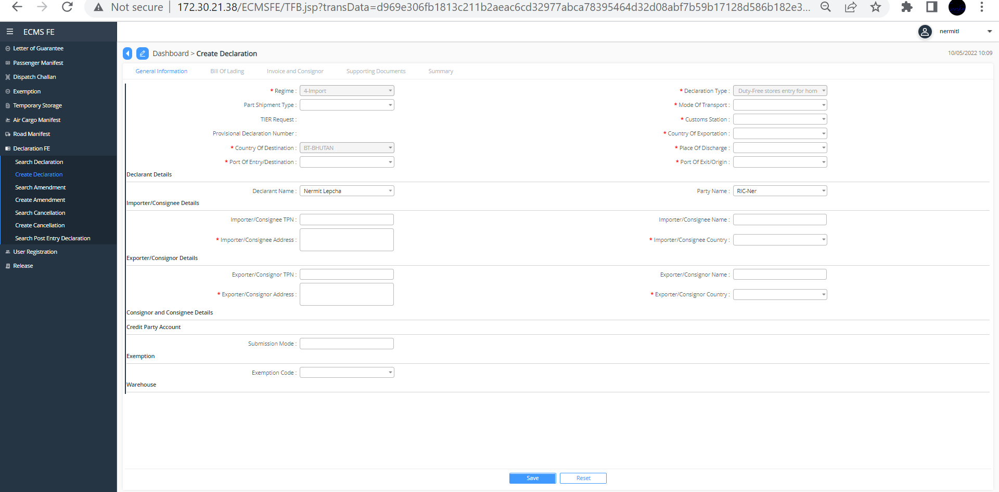
Screenshot for duty free store entry for home use

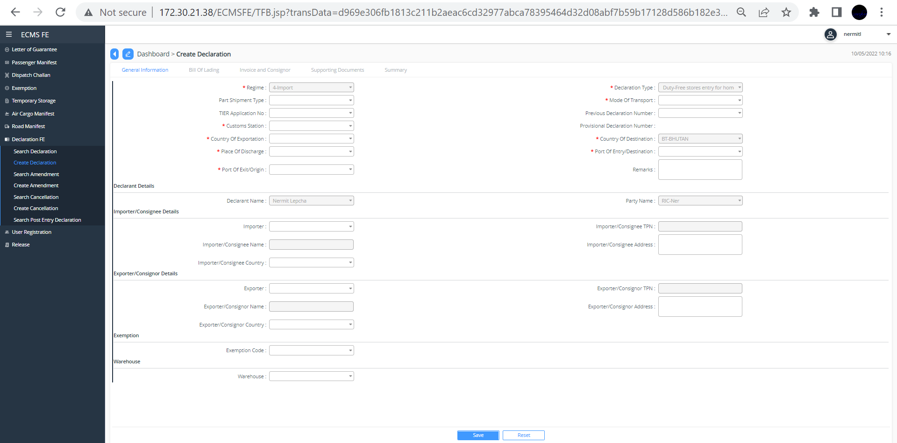
Screenshot for Declaration type: Duty free store for home use without custom duty
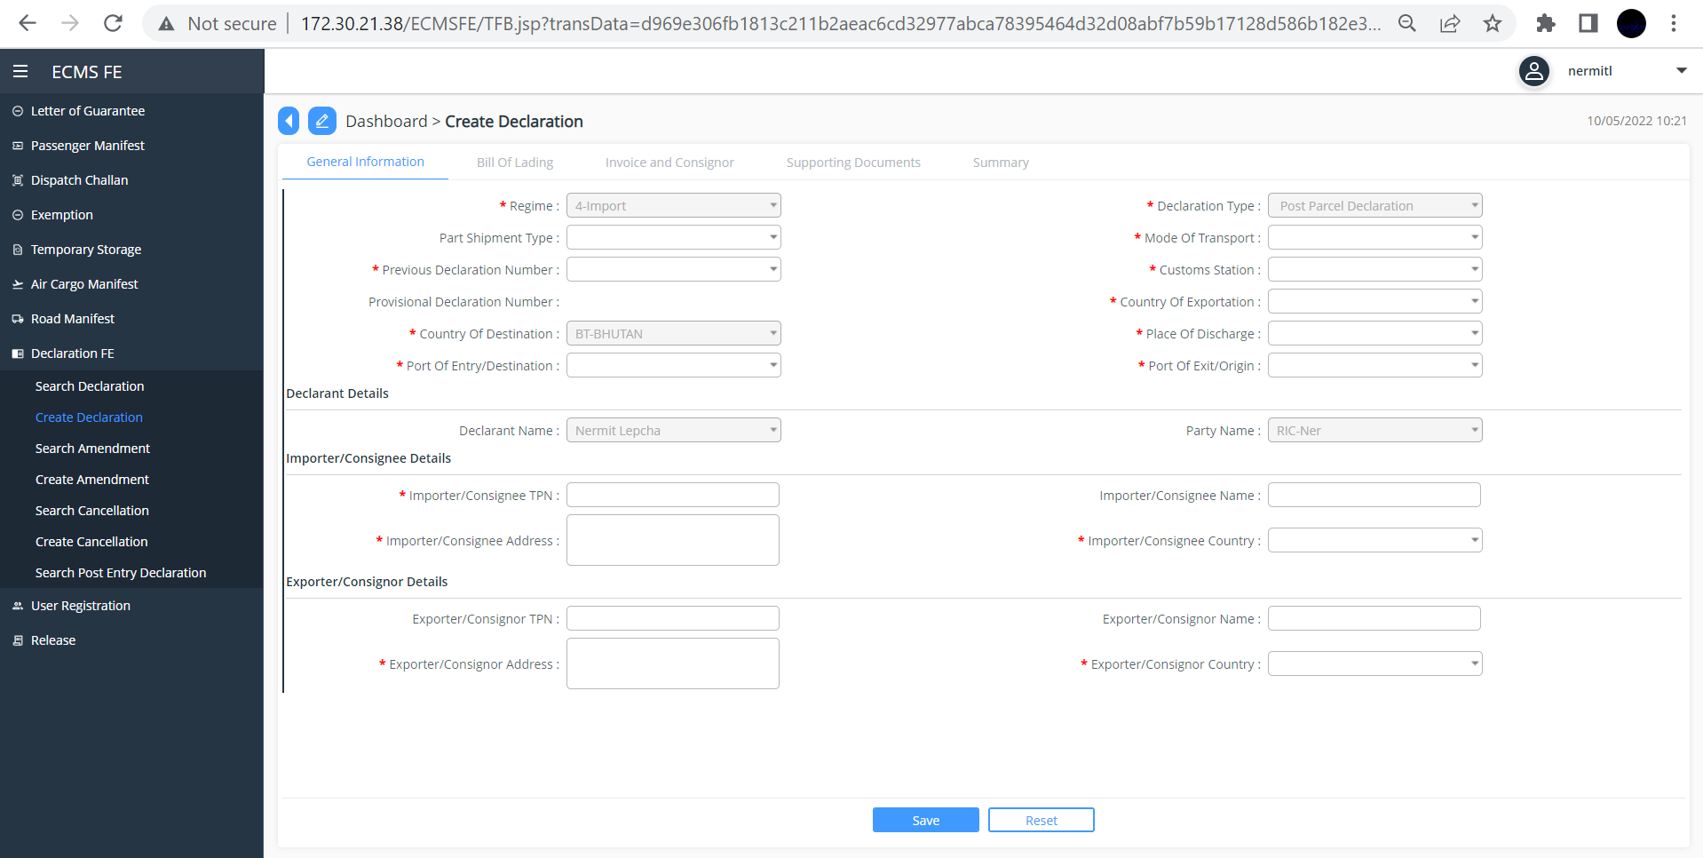
Screenshot for Declaration type: Post parcel Declaration
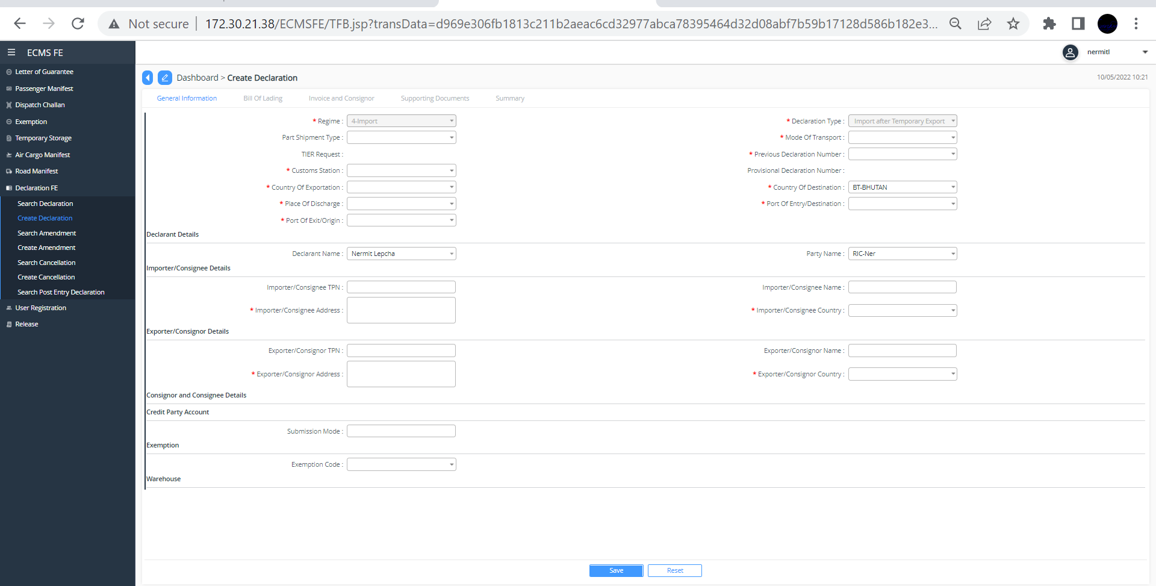
Screenshot for Declaration type: import after temporary export for additional items

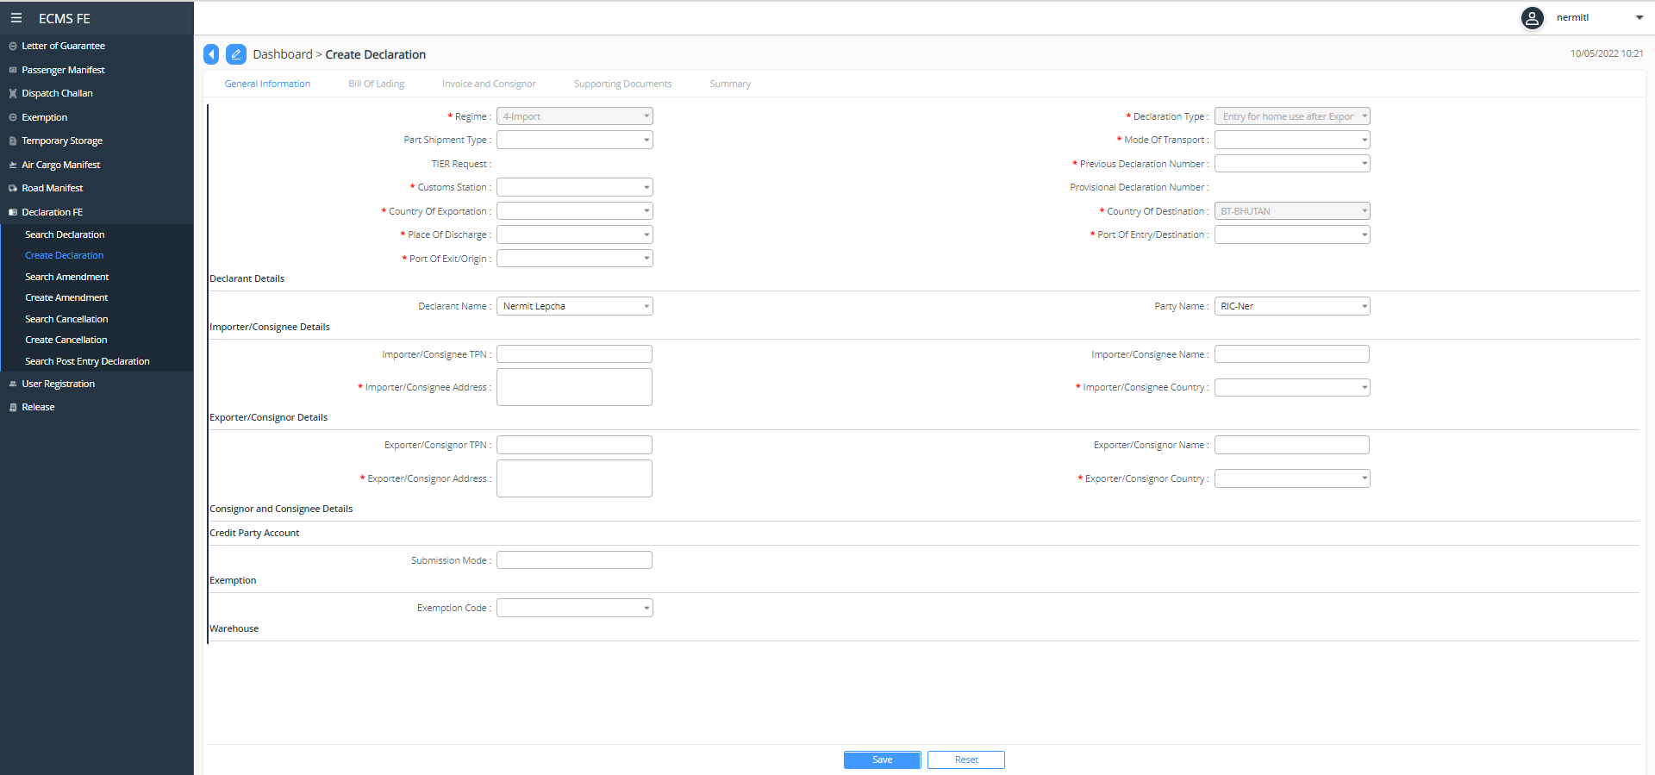
Screenshot for Declaration type: Entry for home use after export of faulty goods.

Export:

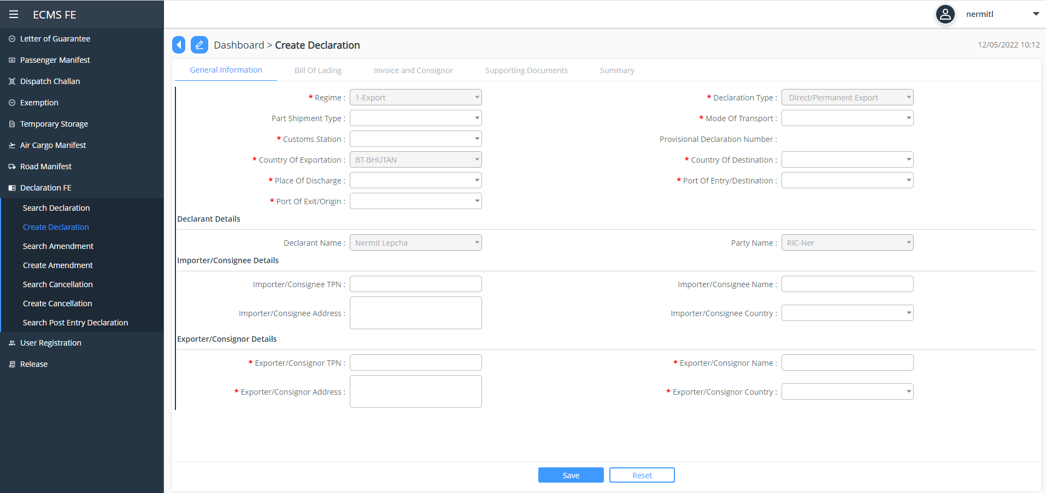
Screenshot for Export for Declaration Type: Direct/Permanent Export

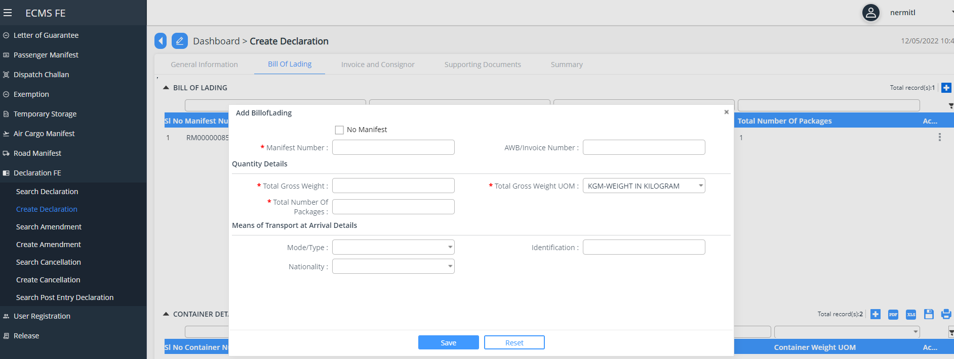
Screenshot for Export: Bill of Lading
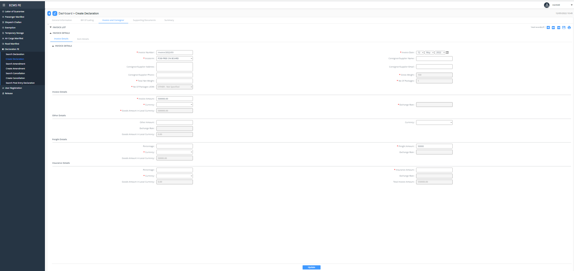
Screenshot for Invoice and Consigner
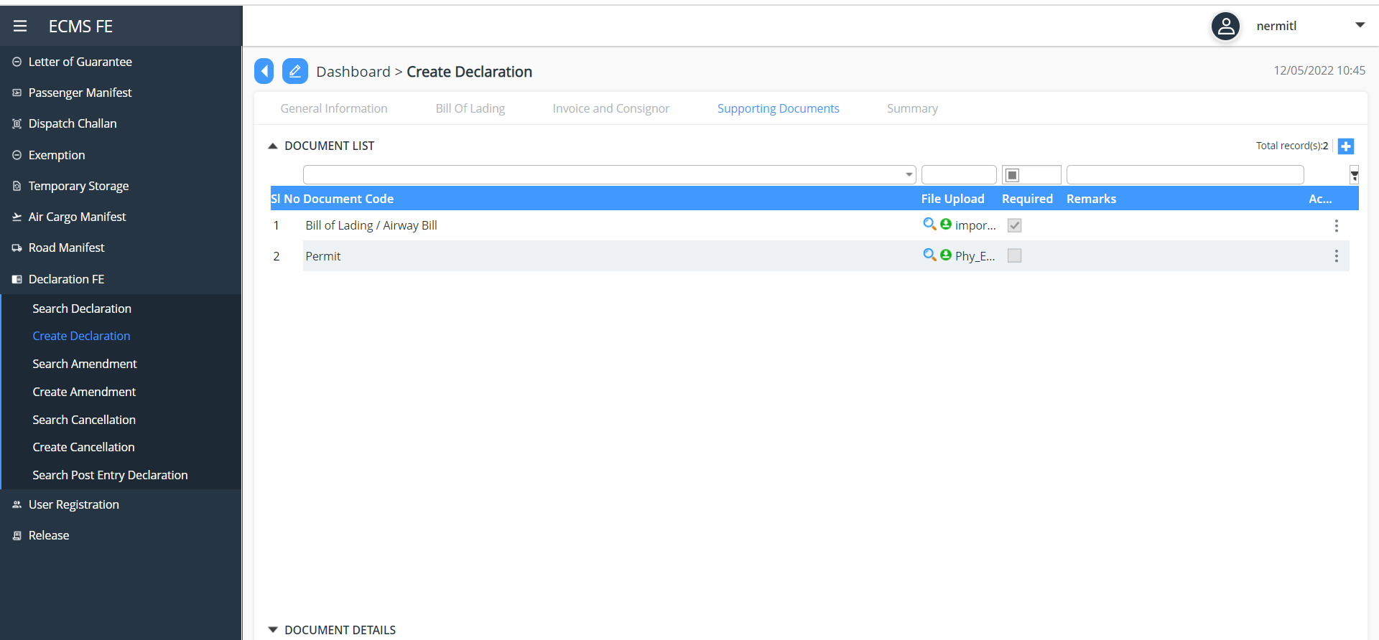
Screenshot for Uploading Supporting Document

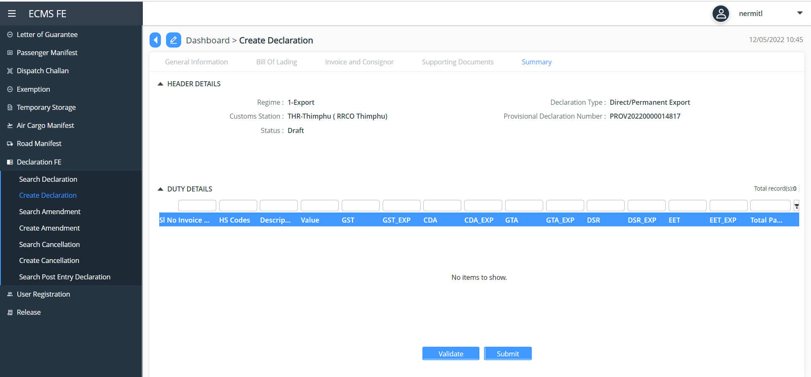
Screenshot for Export Summary

Approval for Export Declaration

Declaration Approval
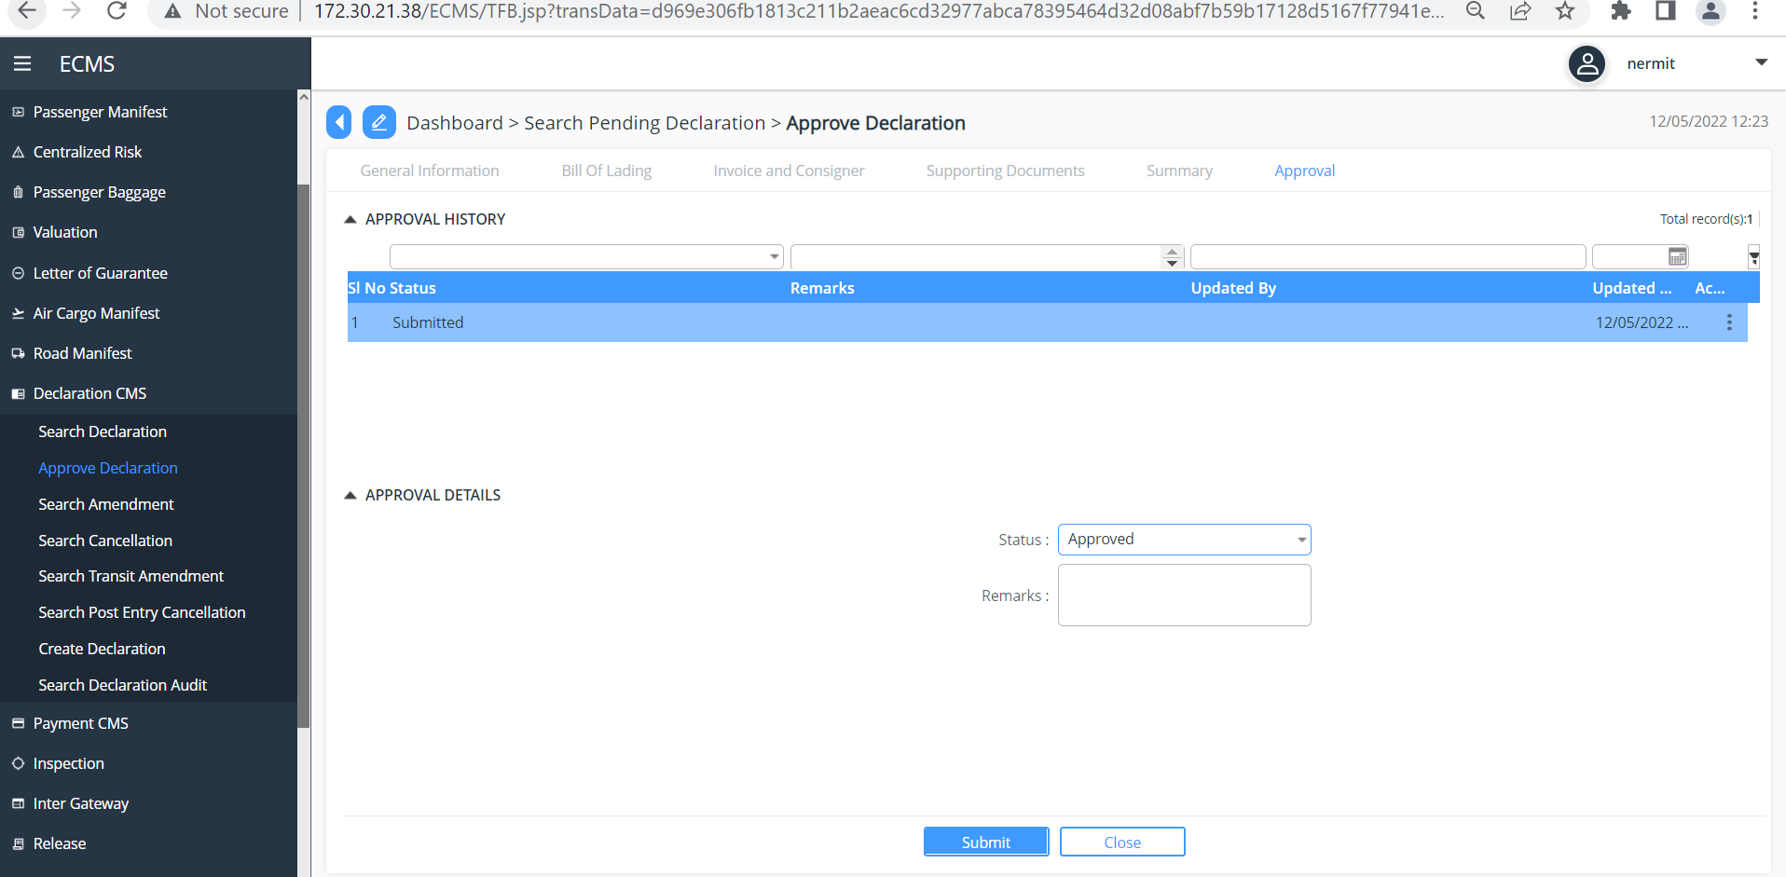

If no payment due move on to Valuation

Export Valuation:

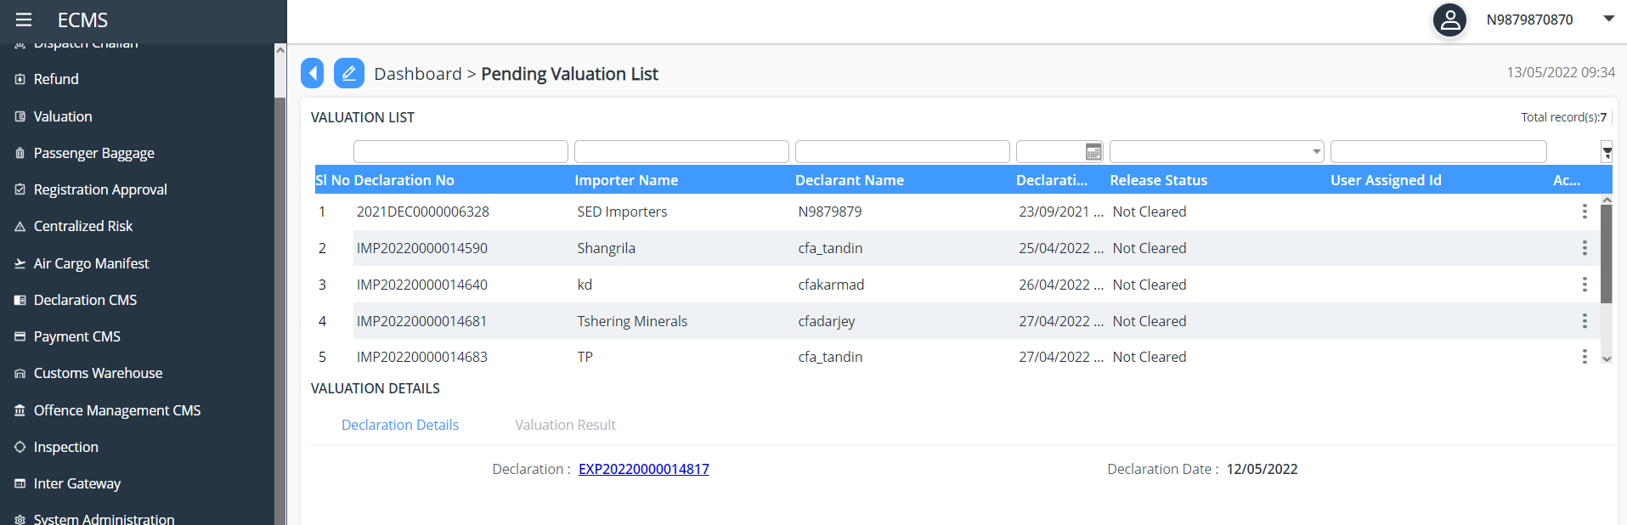

Screenshot for Export Valuation
The valuation officer approves and updates the Valuation result
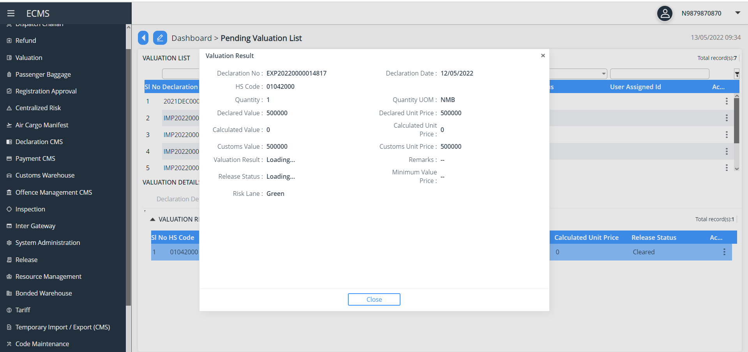
Screenshot for Valuation Result.

Assessment
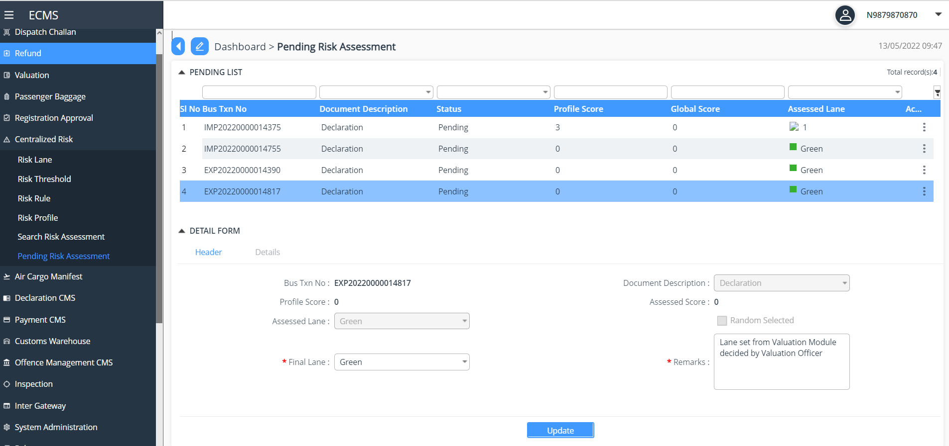
Screenshot for risk assessment

Gate in
After the risk assessment it is forwarded to gate in pass. Post Gate in pass update Cargo details as below:
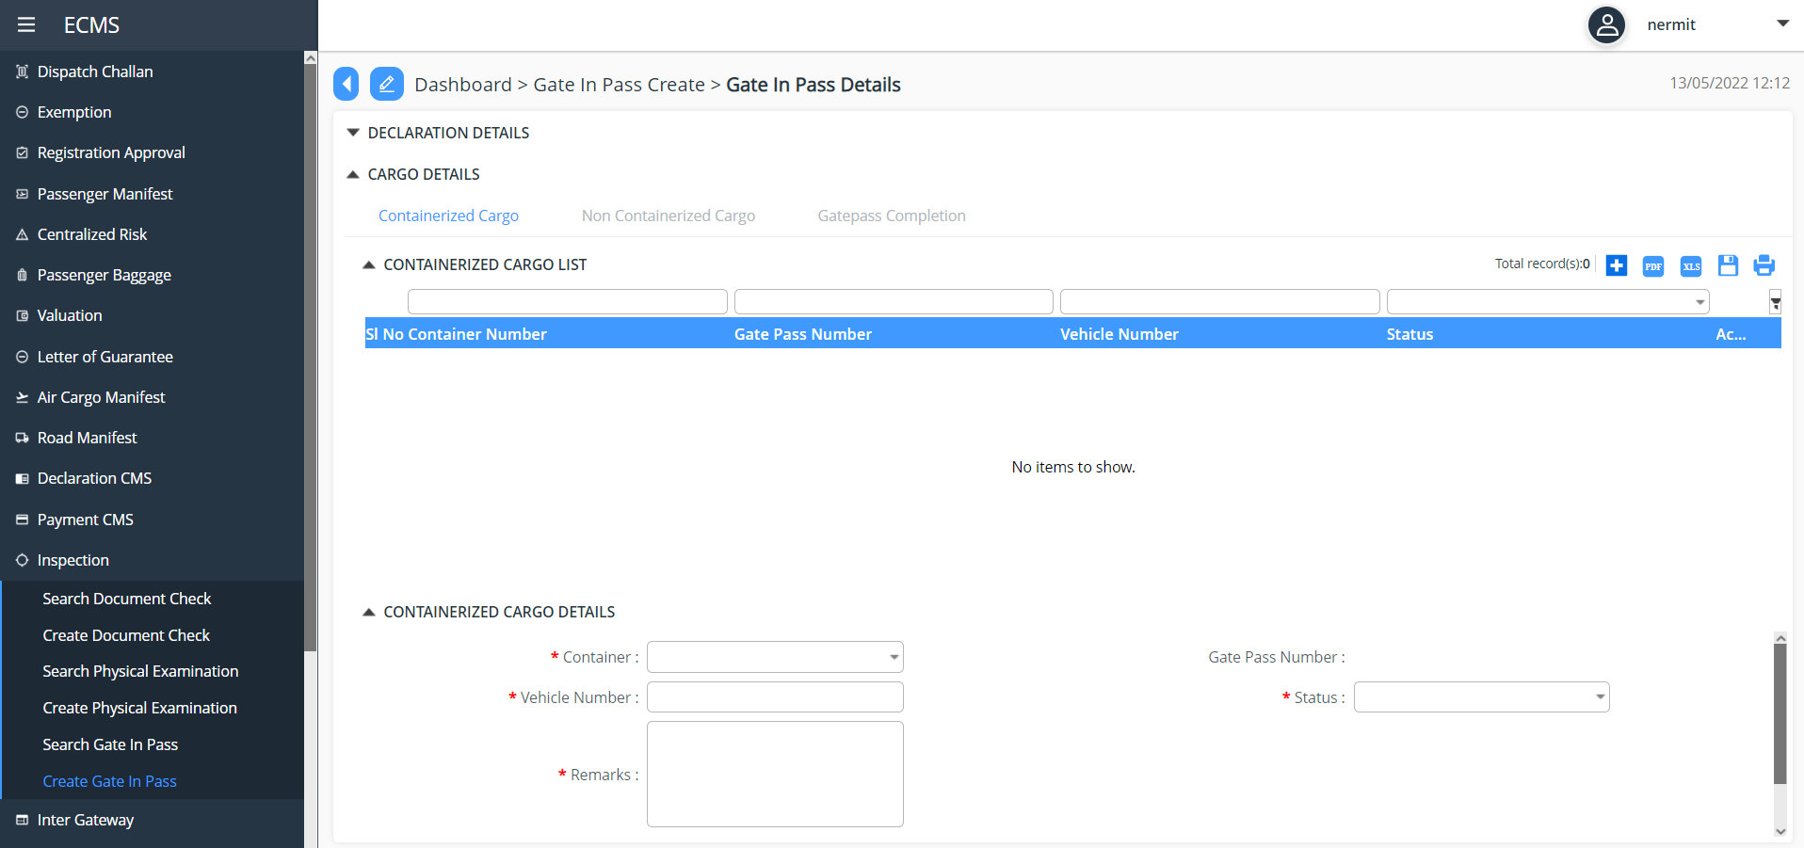
Screenshot to update Containerized Cargo
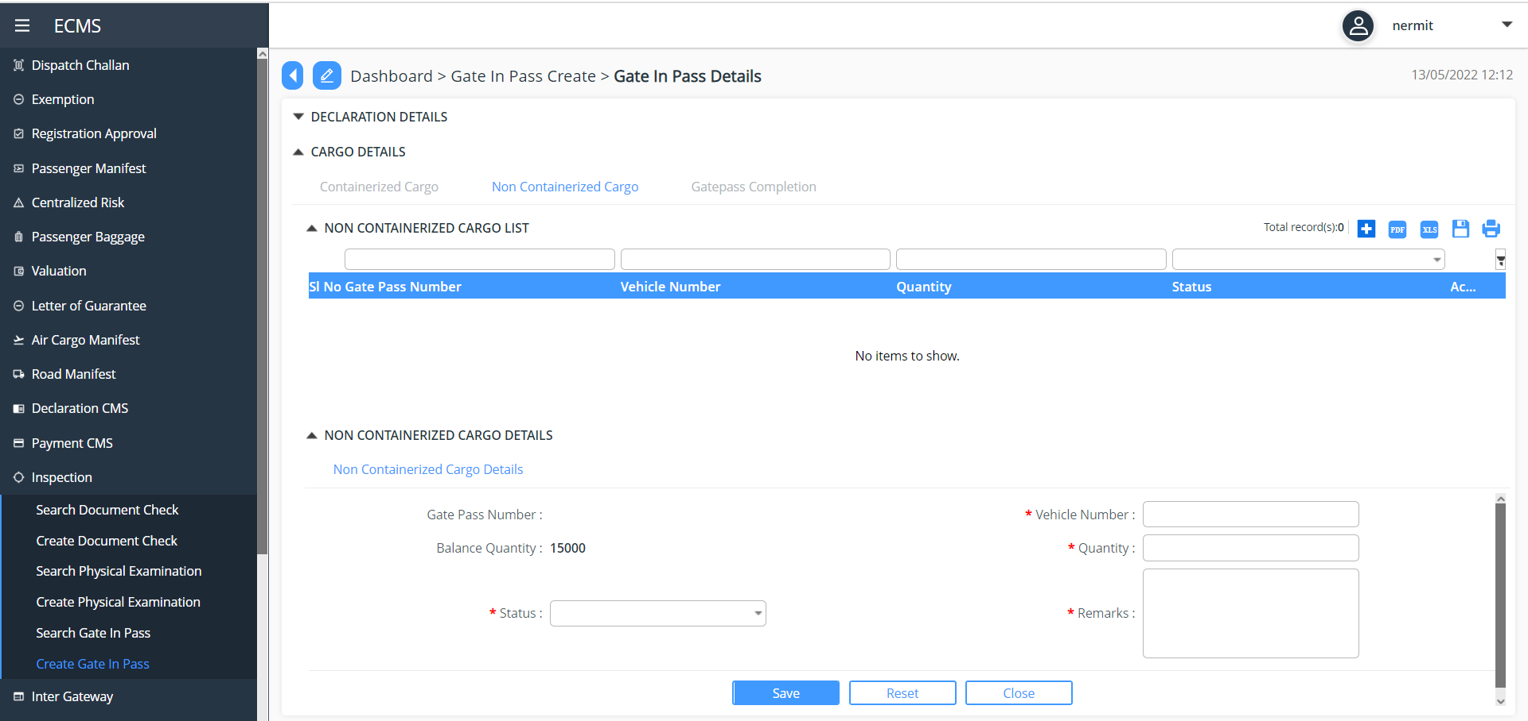
Screenshot to update Non-containerize details

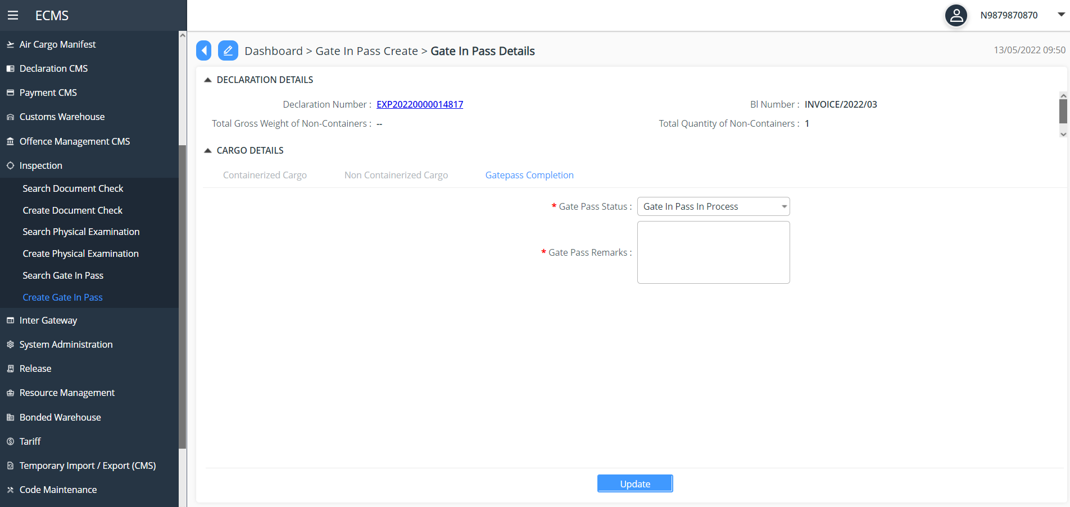
Screenshot for Gate in Pass approval

Dependency Viewpoint

The Application module uses quite a few classes that share information and parameter among themselves to achieve the required functionalities. The package diagram of Application module is provided below:
logging
ORM
data
business
web
Application Controller
Config
exception
Application Service
Config
exception
servicehelpers
ApplicationDAO
Config
exception
daohelpers
mysql-connector.jar
MySQL JDBC Driver
datasource
type
data
values

System Database Schema

ER Diagram
(Example)
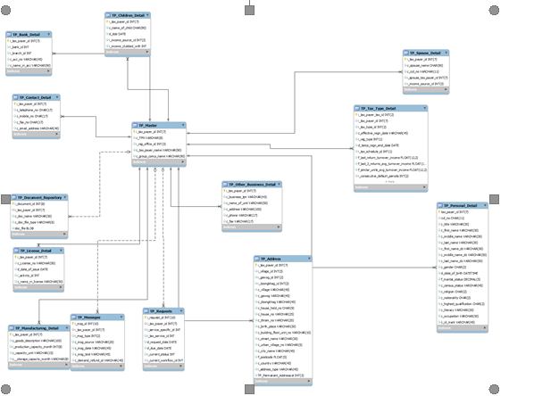

Table Name | Purpose
<Table Name> | <Purpose of the table>

